8.12.2012
Einfluß von Wechselkursen!
Zum 1.1. kostet 1 € = 1,5$. ( Euro ist stark geworden, Dollar ist schwach geworden)
Eine Aktie kostet 3 $ = 2 €
Zum 31.12. kostet 1€ = 1,2 $ ( Euro ist schwach geworden, Dollar ist stark geworden)
Eine Aktie kostet 3,6$ = 20 % Kursgewinn
3,6 $ sind aber 3 €.
In Euro gerechnet habe ich 50 % Kursgewinn ( 2 Euro invest, 3 Euro zurück)

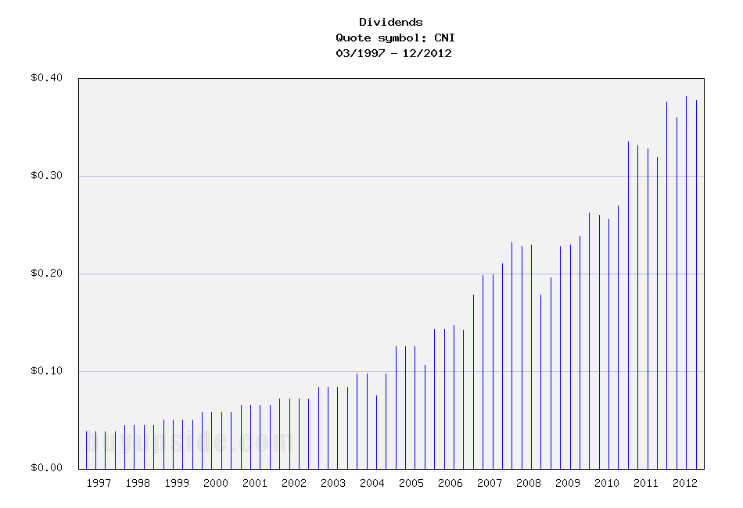
Canadian National Railway: $65/Share is Fair Value (CNI)
Canadian National Railway is a major North American rail business.
-Seven Year Revenue Growth Rate: 4.7%
-Seven Year EPS Growth Rate: 14%
-Dividend Yield: 1.87%
-Balance Sheet: Quite Strong
The quantitative and qualitative factors for Canadian National Railway all look strong. As far as price is concerned, I view the stock as approximately 20% overvalued, and would look for $65 as the threshold for where I’d consider the stock to be a good buy.

Overview
Founded in 1918, Canadian National Railway is the largest railway in Canada and has significant operations in the United States. The rail network extends from the Atlantic Ocean to the Pacific Ocean through Canada, and also extends southward to the Gulf of Mexico through the United States. The total mileage of track exceeds 20,000.
The company is divided into seven commodity groups:
-Petroleum and Chemicals
-Metals and Minerals
-Forest Products
-Coal
-Grain and Fertilizers
-Intermodal
-Automotive

Stock Metrics
Price to Earnings: 15
Price to Free Cash Flow: 26
Price to Book: 3.4
Return on Equity: 22%

Revenue and Free Cash Flow
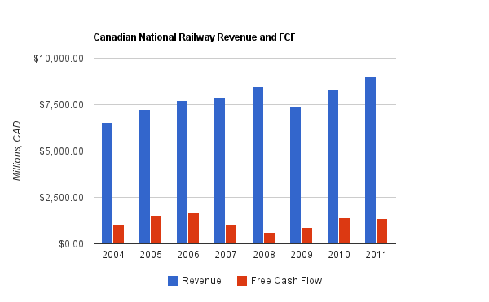
Canadian National Railway grew revenue by an average of 4.7% per year over this period, and grew FCF by only 3.4% annually over the same period.
Revenue growth was fairly consistent with the major exception of the financial crisis which disrupted most companies. Free cash flow, however, grew rather erratically and slowly. This was mainly because operating cash flow was itself rather erratic, while capital expenditures grew rather smoothly and consistently. Capital expenditures actually grew by a compound rate of 6.2% over this period, which outpaced both revenue and operating cash flow, and therefore had a negative impact on FCF. Management expects this continued capital expenditure growth to continue into 2012 as well.

Earnings and Dividends
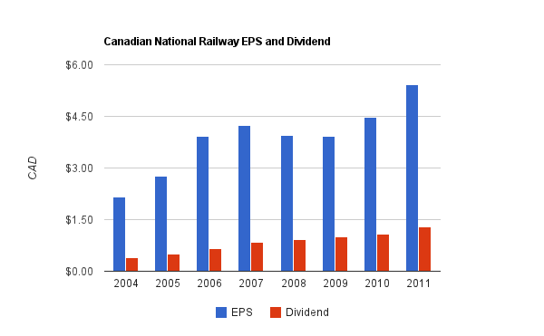
EPS grew by almost 14% annually over this same seven year period, and the dividend grew by over 18.7% annually. The dividend yield is low, at only 1.87%, so the company can benefit from accelerated dividend growth for a while. Eventually, dividend growth must be capped by EPS growth for the payout ratio to stop rising. The dividend payout ratio from earnings is currently under 40% and therefore has plenty of room. The most recent quarterly increase, between 2011 and 2012, was over 15%.
The amount of cash spent on acquisitions over this seven year period was rather low, so most of the free cash was truly free, and able to be given to shareholders. Only about a third of it was paid out in dividends, while the rest went to share repurchases. These share repurchases were a decent value, considering that they accelerated EPS growth to 14% per year compared to only 10% per year for company-wide net income, but as is typical among share repurchases, they weren’t timed very well. The company purchased the fewest shares in 2009 when prices were lowest. The company would do well by shareholders to increase the dividend and decrease the share repurchases.

Balance Sheet
Total debt/equity is only around 60%, and the interest coverage ratio is over 9. These are very strong numbers. Further, total debt/income is under 3.
Overall, the company has a very strong balance sheet.

Investment Thesis
Railroads serve a critical part in world transportation. They remain the most energy efficient way of transporting large amounts of material far distances. From an investing point of view, railways also have among the very strongest of economic moats, in that they are established businesses where new competitors are scarce. Obstacles to starting up a new railway business are obvious, because once track is put down to serve an area, duplicate track would be a poor investment.
The company has several strong indicators:
-None of the seven commodity groups account for more than 20% of revenue, which is solid diversification.
-Further in terms of diversification, 18% of revenue comes from U.S. domestic traffic, 22% comes from Canadian domestic traffic, 28% comes from trans-border traffic, and 32% comes from international traffic.
-Compared to 2009, the ratio of injuries and accidents to person-hours and transportation-miles in 2011, respectively, have decreased.
-The total number of employees is up by 8% at year end of 2011 compared to year end of 2009.
-Recovery since 2009 has been broad, with 6 out of 7 of their commodity groups experiencing increased carloads per year in both 2010 vs 2009 and 2011 vs 2010. The only exception to this was coal, which saw an increase in carloads in 2010 but a decrease in 2011.
Overall, I view Canadian National Railway as a fundamentally solid, albeit cyclical, business. The revenue growth is consistent, free cash flow is fairly strong, and the balance sheet is healthy. The business portfolio has satisfactory diversification and breadth in terms of geography and commodity group. Railways have natural moats surrounding their businesses. A simultaneous pro/con is that capital expenditure is very regular and increasing. It shows management is on top of their priorities for long-term sustainable growth, efficiency, and safety, but when this outpaces revenue growth, there is of course a cost.

Risks
The company is fairly safe from competitors in my view, so the risks are mainly associated with macroeconomic conditions. The company held up well during the recession but was still materially impacted by it, and this will likely be the case during the next recession as well, whenever it occurs. The company has good safety metrics and as previously mentioned, spends considerable sums on capital expenditures, so catastrophic incidents should be rare. My view is that the company is cyclical, but fundamentally solid on all observable quantitative and qualitative matters.

Conclusion and Valuation
In conclusion, I view the company as strong. The next question, then, is what about the valuation?
Based on an assumed free cash flow growth rate of 4% and a discount rate of 9%, I calculate that the stock is overvalued by about 20-25%. In order to justify the current valuation at around $80/share, the long-term FCF growth rate would have to be 5%, with a discount rate of 9%. Based on this, I’d hold off on buying unless the stock drops to about $65, at which time I’d consider it a reasonable value.
151.2.2012
Canadian National Railway (CNI)
The Class I operators in the United States appear to be reasonably valued for long-term returns. The balance sheets are in solid condition, they all have competitive advantages against new competitors entering the market, and some of them pay decent dividend yields.

The Rail Renaissance
Ever since the 1980s when deregulation allowed the rail companies to operate more profitability, railroad stocks in general have enjoyed market-beating returns. Improved automation technologies, increasing congestion of highways (which haven't kept up with increases in car and truck traffic since the construction was initiated under President Eisenhower), and changes in energy costs (railroads are far more efficient with fuel than trucks are), have allowed railroads to improve their operating margins over time.
Investors have different approaches to stocks that have performed well. Some investors believe that buying stocks in an uptrend is a smart buying approach, while other investors believe the exact opposite, and instead look to enter positions after big setbacks.
A more fundamental approach is to ignore previous stock movements, and simply focus on the question of whether the current price is fundamentally undervalued, fairly valued, or overvalued compared to the intrinsic value calculated by estimates of forward-looking performance.
Despite the fact that many of these railroad stocks have already outperformed, some of the most-followed value investors that buy with very long-term horizons are the biggest owners in these companies. Bill Gates, and more specifically through his value-investing chief investment officer Michael Larson, is the largest shareholder of Canadian National Railway (CNI). Warren Buffett took it a step further and acquired the entirety of the Burlington Northern Sante Fe railroad in 2010, and this was his largest acquisition ever.
Based on valuation methods such as the Dividend Discount Model, many of these stocks appear poised to offer returns in the low double-digit range.

Returns Come Mostly From Shareholder Yield, Not Growth
One thing all of the railroad companies have in common is that they are using their free cash flow to buy back their own shares in large numbers and pay moderate-yielding dividends.
The shareholder yield of a stock is the sum of dividends and share buybacks divided by market capitalization.
In other words, if a company pays a 3% yield and buys back 4% of its shares each year (net of shares issued), then the shareholder yield is 7%. That's essentially the expected long-term rate of return the investor gets when 0% core growth is expected. When there is growth, it is on top of the shareholder yield, and the shareholder yield is the internal rate of return the company can keep giving shareholders as long as it has stable free cash flows. If the railroad can boost actual volume by 1-2% per year over the long-term (they've been going a lot faster than that lately, but it's part of a rebound and won't continue indefinitely), and then maintain pricing power of 2-3% increase per year (or in line with whatever the inflation rate is over the period), then another 3-5% rate of return is added onto the shareholder yield.
Investing for the long-term in these railroad stocks, in other words, is basically a bet or estimate that they won't decline in business. As long as they perform flatly, or have 1-2% growth and maintain pricing power, returns can be in the high single digits or low double digits over the next decade. There won't be tremendous growth as there was over the last 25 years, but the industry appears to be a good one to put some capital. The companies can just keep chugging along, reducing the share count and raising their dividends, so that long-term investors can own larger and larger portions of the company and increase the yield on cost.

Risks that Could Threaten the Industry
Authors of articles such as this, this, this, and this (in chronological order), have voiced concerns over the risk that high-speed passenger lines, desired by the federal government, may harm freight railroad companies, or at least show the involvement government has to have with these freight lines in order to proceed.
During the unprofitable period of regulation of railroad stocks, the companies had to serve places that were not profitable to serve. The government proponents of high speed rail currently have to work with the freight companies to use some of their infrastructure, which can impact the efficiency of freight shipping.
It's not a sure-fire problem. With proper planning, passenger trains and freight rail can coexist profitably. Nonetheless, it remains a risk for the industry.
If you like the fundamentals of the industry but want to increase your margin of safety and enter positions with a lower cost basis, selling put options can reduce the cost basis by 10% or so.

How to Play It
The Class I railroads in the United States are Norfolk Southern (NSC), CSX Corporation (CSX), BNSF (owned by BRK.B BRK.A), Union Pacific (UNP), and Canadian National Railway (CNI).
(click to enlarge)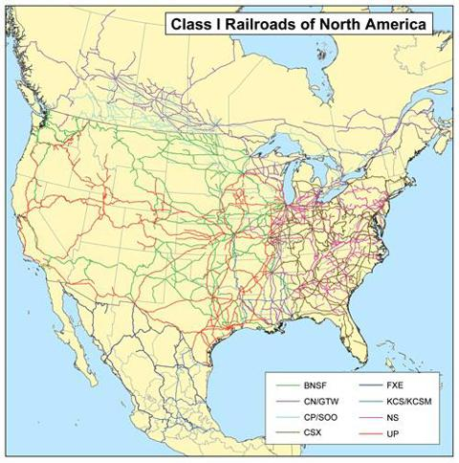
Image source
Focusing on the U.S. rail lines, the railroad stocks are divided into two or three groups.
Canadian Group
While CSX and NSC are rather similar companies on the east side, and UNP and BNSF are rather similar companies on the west side, Canadian National Railway has a distinct position.
There are other Canadian railways, but CNI is the one that has an impact in the United States. They have the privileged position of owning rail lines that stretch from the Atlantic ocean to the Pacific ocean, and then a line that extends perpendicular to that system down to the Gulf of Mexico. They have complete access to all three coasts.
In terms of financials, the company is in similar shape to UNP with a strong balance sheet and a large operation. The operating margins of CNI are the best in the business, but this comes with an earnings multiple of 15. I view this stock as a bit pricey compared to the rest (mainly because its operating margins are already the highest and so there is less room for A decent play to add or increase exposure to railroad stocks is to diversify across an eastern and a western railroad, or CNI and one of the eastern or western railroads.
Here's an overview of the current dividends of each stock:
Company | Yield | Payout Ratio
BNSF (Berkshire Hathaway) | 0% | 0%
Canadian National Railway | 1.65% | 25%
Union Pacific Corporation | 2.23% | 34%
CSX Corporation | 2.81% | 31%
Norfolk Southern | 3.25% | 36%

24.12.2012
Canadian National Railway: A Safe Bet Canada only possesses two national rail companies: Canadian National Railway (CNI) and Canadian Pacific Railway (CP). Of the two, Canadian National Railway is the larger by both track length and geographical coverage. Courtesy of Wikipedia, maps of CNI and CP tracks are provided below (click to enlarge images):
Canadian National Railway -
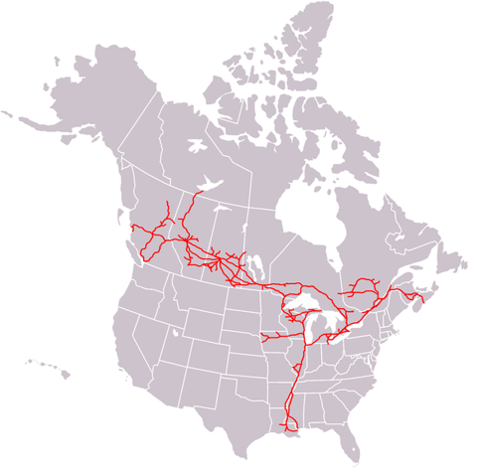
Canadian Pacific Railway -
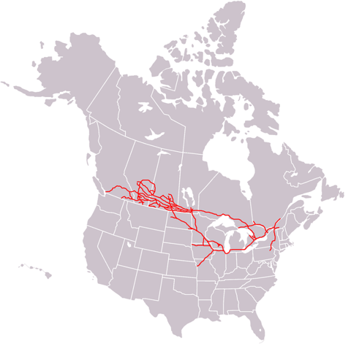
When their performance over the past ten years is compared, Canadian National Railway is the clear winner, being up almost 500% compared to Canadian Pacific Railway's 300%. (These values are for the equities traded on the US exchange; if you are investing in Canadian dollars, your return would be 340% and 180%, respectively, due to the change in exchange rate over the same time period.)
As dividend growth stocks, the yields are not as impressive as the growth rates. Canadian National Railway's yield sits at 1.66% and Canadian Pacific's sits at 1.70%, while distributions have increased by 81% and 52% over the last five years, respectively.
When we look at the financial statements of both railways, the gross profit margins are comparable for both Canadian National and Canadian Pacific at 40% to 43% and 43% to 46%, respectively. For both companies, the depreciation expenses as a percentage of gross profit are comparable, ranging 20-25% over the last five years. However, a more discernible difference is seen when the net earnings of the two are compared: Canadian National has an overall higher percentage of net earnings to total revenues and more reliable yearly earnings increases. Over the last five years, Canadian National has seen between 22% and 27% of its total revenue being net earnings, on a rise since 2008 after a decrease from 27% to 22% from 2007 to 2008. Canadian Pacific, on the other hand, is only at 11% this year after seeing 19% in 2007. The net earnings of Canadian National have also shown an increase of 16% and 13% in the last two years, respectively, whereas Canadian Pacific has -12% and 18% for the same years.
When we look at the debt of both companies, the assets to liabilities ratio of both are over 1, with Canadian National's being slightly higher (ranging from 1.64 to 1.79 compared to Canadian Pacific's 1.49 to 1.59). Neither shows any distinct trend over the last five years, nor any clear advantage of either. However, when we look at how long it would take for each company to pay off their debt with their net earnings, Canadian National comes out the clear winner, requiring only 2.4 years to be fully paid off. This is at the low end of what has been seen over the past five years, where the time to pay off long-term debt has ranged from 2.4 to 3.5 years. Canadian Pacific is in far worse shape, requiring 8.3 years to pay off all long-term debt in 2011.
Both companies have successfully increased retained earnings over the past five years. The table below indicates the superior increase in retained earnings of Canadian National compared to Canadian Pacific.
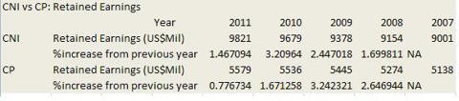

27. Dezember 2012, 14:46 Uhr

Kanalerweiterung

Panama-Flutwelle trifft deutsche Häfen
Von Markus Gärtner
In einem Jahr wird die Erweiterung des Panama-Kanals für Megafrachter abgeschlossen. Der Gewinner steht bereits fest: China. Deutsche Häfen wie Hamburg drohen im Kampf um die Superschiffe leer auszugehen.
Vancouver - Mit der Jahreswende rückt der nächste Meilenstein in der Globalisierung näher. Die Erweiterung des 77 Kilometer langen Panama-Kanals wird in einem Jahr abgeschlossen sein. Der künstliche Wasserweg revolutionierte 1914 mit seiner Fertigstellung den globalen Güterhandel. Er verkürzte den 22.000 Kilometer langen Seeweg von New York nach San Francisco auf 9600 Kilometer, weil die lange Umrundung des südamerikanischen Kontinents seitdem entfällt.
Derzeit wird letzte Hand an die dritte Spur des Kanals angelegt und zwei supergroße Schleusen zu Ende gebaut. Dann können sich die Megaschiffe der Post-Panamax-Klasse durch den Kanal schieben. Sie sind doppelt so groß wie bisher und führen mit 15.000 Containern drei Mal so viel Fracht.
Die Folgen für den Welthandel sind weitreichend und machen Hafendirektoren und Frachtmanager bis nach Hamburg ziemlich nervös. Denn die Post-Panamax-Schiffe machen trotz eines Anteils von erst 16 Prozent der Flotte bereits 45 Prozent der Frachtkapazität auf den Weltmeeren aus. Bis 2030 soll ihr Kapazitätsanteil auf 62 Prozent steigen. Der erweiterte Panama-Kanal wird ein großer Treiber dieser Entwicklung sein.
Von den USA bis nach Europa sind jedoch nur wenige Häfen im Zeitplan mit der nötigen Vertiefung von Hafenbecken und Brückenvergrößerungen, um die rasch wachsende Zahl der Ozeanriesen mit ihrer vollen Last aufzunehmen. Während die Nachzügler in diesem Wettlauf gegen die Uhr kämpfen, reiben sich die großen Gewinner bereits die Hände: Asiens, vor allem Chinas Zugang zu den großen Absatzzentren im Osten der USA wird billiger, schneller und leichter.
Kanalerweiterung hilft US-Industrie
Viel von der Fracht aus Fernost - Spielzeuge, Maschinen, PCs und Elektronik - wird bislang an der Westküste der USA in Häfen wie Los Angeles und Long Beach gelöscht. Dann werden die Container auf LKW gehievt oder auf Eisenbahnen verladen und quer durch die USA zu den Kunden gebracht.
Mit den Ozeanriesen, die künftig den erweiterten Panama-Kanal durchqueren können, ist es weitaus billiger, die Güter gleich in Häfen an der Ostküste zwischen Florida und New York zu bringen. Dort freut man sich, denn das zusätzliche Frachtvolumen mit Asien kann zumindest einen Teil der verlorenen Volumina im Handel mit dem rezessionsgeplagten Europa ausgleichen.
Mehr noch: Der leichtere Zugang für billig verschiffte Massenware und Maschinen wird die Rückverlagerung von Industrie nach Amerika - die vom lokalen Energieboom schon angestoßen wird - noch beschleunigen. Der Renaissance des verarbeitenden Gewerbes in den USA wird das helfen. Nicht über Nacht, aber trotzdem spürbar. Bereits sichtbar ist der neue Trend mit Ansiedlungen von Airbus in Mobile, Boeing in Charleston und Caterpillar in Athens, Georgia.
Und China, Indien und anderen Schwellenländern in Fernost wird die Verbreiterung des Panama-Kanals zusätzliche Handelsvorteile bescheren. Denn Rohstoffe und Agrarprodukte aus Südamerika - von Eisenerz und Sojabohnen aus Brasilien bis hin zu Öl aus Venezuela - werden durch den erweiterten Panama-Kanal ebenfalls einfacher, billiger und schneller nach Fernost transportiert werden können. Chinas massiver Energiegunger wird sich noch besser stillen lassen.
China für mehr Länder wichtigster Handelspartner als USA
Kein Wunder, dass die Chinesen über den reinen Kanal längst hinausdenken. Kolumbiens Präsident Juan Manuel Santos hat preisgegeben, dass seine Regierung Gespräche mit China führt, um einen "trockenen Panama-Kanal" zu bauen. Gemeint ist damit eine 7,6 Milliarden Dollar teure Eisenbahnstrecke durch Kolumbien mit dem Ausbau des Hafens am Ende der Zugverbindung, um der Volksrepublik einen besseren Zugang zu Lateinamerika zu bescheren.
Der vergrößerte Panama-Kanal stellt für China, das seit der Finanzkrise in zahlreichen Ländern der Welt die USA als führenden Handelspartner ablöste, einen weiteren strategischen Coup dar. Waren die USA 2006 noch der wichtigste Handelspartner für 127 Nationen - im Vergleich zu China mit lediglich 70 - so hat sich das Verhältnis seitdem völlig umgekehrt. Jetzt ist die Volksrepublik der wichtigste Handelspartner von 124 Ländern, die USA sind es nur noch für 76.
Aber auch die Schwellenländer auf der westlichen Hälfte Südamerikas können die Erweiterung des Panama-Kanals feiern. Denn auch Chile, Peru und Kolumbien erhalten besseren Zugang zur Ostküste der USA. Selbst im fernen Kanada, dem größten Handelspartner der USA auf dem Doppelkontinent, gibt es Gewinner. In Halifax zum Beispiel kann der Tiefseehafen künftig mehr von den modernen Ozeanriesen mit bis zu 15.000 Containern aufnehmen.
Verlierer aber werden die Häfen an der Westküste der USA sein. Zwei Drittel der Fracht, die im Hafen von Seattle anlandet, wird auf der Schiene in den Mittleren Westen befördert. Vieles davon wird künftig direkt durch den Panama-Kanal an die Ostküste schippern.
Aufrüstung der Häfen im Osten der USA kommt spät
Vor allem an der Ostküste der USA ist daher fieberhaft die Vorbereitung auf das Zeitalter der Megaschiffe im Gange. Die Häfen im Osten der USA haben ohnehin 2012 zum ersten Mal seit dem Zweiten Weltkrieg den Westhäfen in den Staaten Washington, Oregon und Kalifornien die Tonnage-Führung abgerungen. Das ist einer Studie des Immobiliendienstleisters Colliers International vom August zu entnehmen.
Die Aufrüstung der Häfen im Osten der USA kommt spät, wie viele in der Frachtbranche finden. Während die Westküste dank ihrer tiefen Pazifikhäfen schon lange die neuen Frachtriesen aufnehmen kann, werden bis zur Eröffnung der dritten Spur des Panama-Kanals nur drei Häfen bereit für die Reederei-Riesen des Panama-Kanal-2.0-Zeitalters sein: Baltimore bis 2013, Miami bis 2014 und Norfolk (bereits fertig). New York kämpft noch mit der Vertiefung des Hafenbeckens im Jahr 2013 und vor allem mit der Erhöhung der Bayonne-Brücke, die für eine Milliarde Dollar bis 2016 angehoben werden soll. Die Häfen in Charleston, Jacksonville und Port Everglades wollen bis 2017 ebenfalls ihre Becken auf 50 Fuß vertiefen.
Aber nicht nur Hafendirektoren und Shipping-Magnaten sehen der Fertigstellung des erweiterten Panama-Kanals aufgeregt entgegen. Auch Bauentwickler, Investoren und Supply-Chain-Strategen fiebern dem neuen Zeitalter entgegen. An der gesamten Ostküste der USA - sowie rund um die Häfen am Golf von Mexiko - werden Lagerhäuser, zusätzliche Terminals und Logistikzentren gebaut. "Kapital aus den privaten und öffentlichen Sektoren fließt reichlich in die gesamte Infrastruktur im Großraum der Häfen, es konzentriert sich auf Lagerhallen und Distributionszentren", erklärt John Carver, der Chef bei Jones Lang LaSalle für das Geschäft mit Häfen und globaler Infrastruktur.
Wer sich auch freuen darf, sind Amerika Bauern. Weizenexporte aus dem "Farm Belt" im Mittleren Westen, die über den Golf von Mexiko verschifft werden, haben nun bessere Marktchancen in Asien.
Elbvertiefung in Hamburg vorerst gestoppt
Welche direkten Folgen der erweiterte Panama-Kanal für die Wettbewerbssituation europäischer Häfen hat, ist schwer abzuschätzen. Aber der Wettbewerb um die Containerriesen, deren Anteil durch den erweiterten Kanal beschleunigt steigen dürfte, wird zunehmen.
Die Elbvertiefung in Hamburg verzögert sich bekanntlich. Das Bundesverwaltungsgericht in Leipzig stoppte erst im Oktober die Verbreiterung und Vertiefung der Elbfahrrinne. Klagen von Umweltverbänden sollen gründlich geprüft werden. Wie lange das dauert, weiß niemand. Klar ist derweil nur: Immer häufiger kommen Großcontainerschiffe zwischen Asien und Europa zum Einsatz. Führender Zielhafen für den Chinahandel in Europa ist bisher Hamburg.
Die chinesische Großreederei China Shipping weicht mit Megaschiffen nach eigenen Angaben bereits in Konkurrenzhäfen an der Nordsee aus. Zwar konnte das weltgrößte Containerschiff - die CMA CGM Marco Polo - erst kürzlich die Elbe hinauf nach Hamburg fahren. Doch die Ladekapazität von 16.000 Standardcontainern wurde nur zu einem Viertel ausgelastet, sonst wäre die Marco Polo in der Elbe stecken geblieben.
Deutsche Häfen könnten trotzdem profitieren
Ob deutsche Häfen deshalb als Verlierer dastehen müssen, wenn es nicht zur Vertiefung kommt, ist auch nicht ganz klar. Denn auf der Welt gibt es drei stark befahrene Hauptrouten: Von Asien nach Europa, von Asien nach Nordamerika und über den Atlantik zwischen Europa und Nordamerika.
Die beginnende Verlagerung von Produktion aus China nach Indien und Südostasien wird zu mehr Frachtvolumen über den Suez-Kanal führen und ohnehin für mehr Frachtvolumen sorgen. Und der erweiterte Panama-Kanal könnte einigen europäischen Reedern für das China-Geschäft Alternativen bieten, weil die Route durch den Suez-Kanal mit höheren Versicherungskosten behaftet ist, dank der Spannungen im Nahen Osten und der somalischen Piraten.
Immerhin: Die für den Seehandel zuständigen Minister der EU haben im Oktober die sogenannte Limassol-Deklaration auf den Weg gebracht. Sie räumt der Entwicklung der Hafeninfrastruktur in Europa mehr Priorität ein. Nötig ist das: Etwa 75 Prozent von Europas Außenhandel wird auf dem Seeweg abgewickelt.

2.1.2013
Canadian National Railway: A Definitive Value Play
Overview
As I previously mentioned, CNI's operations revolve around the rail and related transportation business. CNI's network consists of approximately 21,100 route miles that span Canada and mid-America, from the Atlantic and Pacific oceans to the Gulf of Mexico, serving the ports of Vancouver, Prince Rupert, British Columbia, Montreal, Halifax, New Orleans, and Mobile, AL and the areas of Toronto, Buffalo, Chicago, Detroit, Duluth, Minnesota/Superior and Green Bay, WI, Minneapolis/St. Paul, Memphis and Jackson, MS, in North America. In addition, CNI's extensive network, and its co-production agreements, routing protocols, marketing alliances and interline agreements, provide its customers with easy access to all three North American Free Trade nations. CNI turns over the greatest profit and produces margins for investors that are significantly greater than any railroad company in North America. Figure 1 illustrates CNI's strong levels of profitability have rewarded investors over the past five years.
Figure 1: CNI's Five Year Price Graph
(click to enlarge)
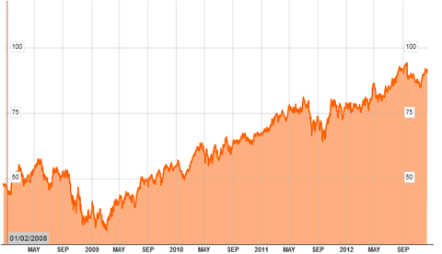
Relative Performance
To further illustrate CNI's performance, I constructed a graph below using YCharts that compares the relative performance of CNI and its peers benchmarked to the S&P. The peers used in figure 2 below include Norfolk Southern Corp (NSC), Union Pacific Corp (UNP), CSX Corp (CSX), and Kansas City Southern Corp (KSU).
Figure 2: CNI's Relative Performance
(click to enlarge)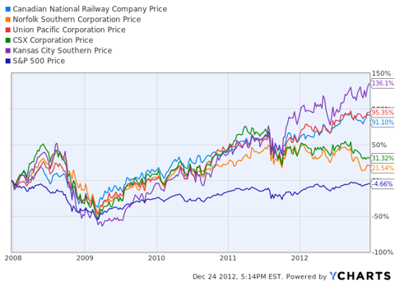
In addition to the growth exhibited by CNI over the past five years, KSU also reveals a strong pattern of growth and has the potential for a substantial upside from its current value in the short-run. However, KSU is not CNI and its operating efficiency in not there for surpassing CNI in terms of stable long-term growth. CNI substantial profit margins and ability to generate and maintain high levels of free cash flows ultimately add value to CNI as a firm and are crucial to what will enable CNI to outperform the market as well as its peers over the next five years.
Capital Structure
For a company operating in the railroad industry, CNI reveals capital structure that is higher than the average target of its peers. In practice, it is common to often see companies operating in the railroad industry to carry a sufficient large amount of debt, which is the case for CNI. CNI's current debt to equity ratio is approximately 0.57 and as you will see in figure 3 below that a high debt to equity ratio is rather common for CNI. While in many cases a high level of debt financing raises concerns for investors, however CNI's high EBIT to interest coverage ratio of 9.7 makes this factor irrelevant.
Figure 3: CNI's Debt/Equity Ratio Past Five Years
(click to enlarge)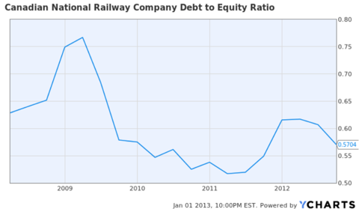
Valuation
Among its peers CNI maintain the lead in generating free cash flow from their high returns on equity. CNI exhibits extreme growth in its level of free cash flows in the last five years. Figure 4 below illustrates this increase and you will see CNI's free cash flows have increased over 800% over this period. More specifically, CNI's current value of free cash flows is $508.95 million.
Figure 4: CNI's Five Year % Change in Free Cash Flows
(click to enlarge)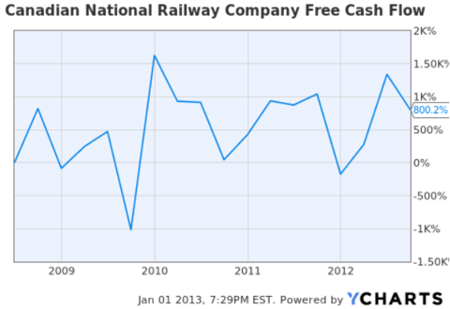
From a brief glance below, CNI is fairly price along side if its peer UNP whose P/E ratios are right around 15x. Note KSU, who also exhibited peak performance over the same time period as CNI, is not fairly priced. KSU's P/E ratio is nearly 24.13.
Figure 5: P/E Ratios TTM of CNI versus Peers
(click to enlarge)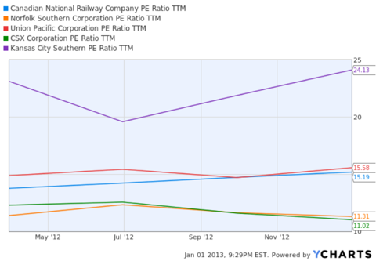
Value of Equity and Operations
Nearly 82.59% of CNI's common stock outstanding is owned by a combination of insiders and institutional investors, with institutions owning approximately 73.06% and the remaining 9.53% by insiders. The remaining 26.94% is owned by individual investors with a majority of the owners residing within the U.S. From a current valuation standpoint focusing on free cash flows and the value of operations, I estimated CNI is trading about 8% below fair value. Now this alone is insignificant for denoting it to be a value play with an extreme short-term upside, however CNI's managements history of repetitive buy backs is taken into account and incorporated into modeling the intrinsic value of CNI, the end result it rather appealing.
To evaluate the potential upside for investors, I used the corporate valuation model. The objective of this model is to calculate the intrinsic value of the firm based on the future value of operations by first projecting free cash flows forward. It then uses a modification of the constant growth model taking into account the firm's expected growth rate and weighted average cost of capital estimate. This allowed me to derive an intrinsic share value for the following years. Figure 8 below provides a two-case scenario modeling an intrinsic value that is precise, yet conservative. For clarity, the variation between the inputs used and the outputs derived are distinguished by red and orange text respectively.
Figure 6: CNI & The Corporate Valuation Model
(click to enlarge)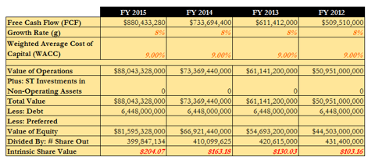
The free cash flow estimate I used for the first period was the most recent value available and for the remaining estimates I used conservative approximations for the free cash flow values. Using CNI's weighted average cost of capital, 9% and a constant growth rate of 8% I computed an intrinsic share value of $103.16 for the end of FY 2012. Using the same methods I calculated the intrinsic share value estimates for FY 2013, FY 2014, and FY 2015 as well. The only alterations I made to the model were the number of shares outstanding for FY 2013 through FY 2015. As I previously mentioned, CNI's management has displayed a history of repurchasing shares outstanding from investors and for greater accuracy I have factored this in the model provided below.
Conclusion
CNI's favorable operating ratios tend to be heavily admired by investors who are long advocates of CNI. High profit margins and excessive sums of free cash flows have yielded favorable returns for investors in recent years. CNI has established a capital structure that may be high relative to its peers, but is optimal in relevance to CNI's operations. In addition, intrinsic valuation estimates are highly favorable and in support of stable growth in the firm's operations over the next few years. While CNI is an investor friendly company and provides for great long-term investment, it is essential investors enter and purchase shares at the right time. CNI's market value per share is high, but its P/E ratio is fair. That being said, the practice of dollar cost averaging when accumulating shares of CNI for a portfolio with the objective of long-term growth is crucial for initiating a strong position in CNI.

17.2.2013
Canadian National Rail Has Catalysts For Growth
In my opinion, CNI owns the best track system in North America as it is the only railroad that has tracks that cross the continent from east to west and north to south. CNI serves ports on the Atlantic, Pacific and Gulf of Mexico. CNI also has exclusive rights to Prince Rupert Port in British Columbia. Prince Rupert is the closest North American port to China which allows CNI to carry a great deal of Chinese imports into North America.
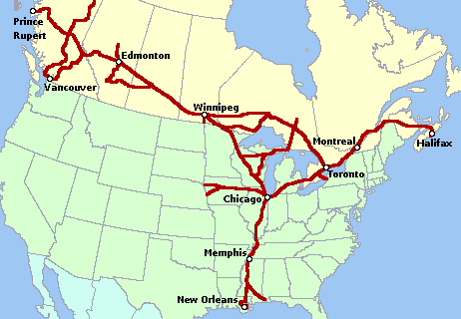
The most recent quarterly earnings report showed CNI had record volumes and earnings. Revenue and earnings increased 8% and cash flow continued to increase. Train productivity increased by 2%, yard throughput increased by 6% and car velocity increased by 4%. This continued focus on productivity led to a best in class operating ratio of 63.6%. Operating ratio measures the amount of revenue needed to run the railroad, the lower the number the better. For comparison, Union Pacific (UNP) had a 4th quarter operating ratio of 67.1%, CSX (CSX) had full year operating ratio of 70.6%, Norfolk Southern (NSC) had 4th quarter operating ratio of 73.4% and Canadian Pacific (CP) had a 4th quarter ratio of 74.8%. (CNI information can be found here).
Canadian National carries a wide range of products, most of which saw nice gains in the 4th quarter and for the full year. The chart below breaks out the products and the favorable or unfavorable revenue improvements, in constant dollars, for the quarter and full year.
Product | 4th QTR 2012 Rev | 4th QTR 2011 Rev | 4th QTR % Change | Full Year 2012 REV | 2012 % Change
Petroleum | $427M | $377M | 16% | $1,640B | 15%
Metals % minerals | $274M | $278M | 1% | $1,133B | 12%
Forest | $323M | $329M | >1% | $1,331B | 4%
Automotive | $128M | $122M | 7% | $538M | 10%
Coal | $171M | $149M | 17% | $712M | 15%
Grains & Fertilizer | $459 | $413 | 13% | $1,590B | 4%
Intermodal | $498M | $464M | 8% | $1,994B | 11%
As you can see by the above chart, CNI has a well-balanced product portfolio, which allows CNI to minimize large earnings decline when one of the categories slows down. Unlike other railroads, CNI had an improvement in their coal traffic in 2012 which is a result of the increase in metallurgical and thermal coal export. CNI's multiple port access allows CNI to benefit from the increased exporting of coal, despite the weakness in U.S. coal demand for power generation.
For 2013, CNI sees modest economic growth in North America resulting in 3 to 4% carload growth and high single digit growth in "Earnings per Share." CNI has recently hit 52 week highs and trades at just under $100.00 a share. CNI closed on January 2nd at $92.27 and trades, as I write this, at $99.67, a gain of about 8% for the year. Despite reaching a 52 week high, CNI trades a fair value P/E of 16 and has a P.E.G. (Price to Earnings Growth) of 1.41.
Canadian National pays a modest dividend of $1.72 (Canadian Dollars) which is a yield of 1.70%. Using David Fish's excellent DRiP Investing Resource Center, we see CNI is a Dividend Contender, having raised its dividend 17 consecutive years. The dividend growth rate has averaged 18% over the last 10 years and 19% over the last 3 years. With a dividend payout ratio of only 28%, CNI does have the ability to continue increasing the dividend. Amongst its railroad peers, CNI is the lowest yielding stock, with the exception of CP.
The Catalysts
Oil Sands
The Canadian Oil Sands area in Alberta helped increase CNI's petroleum car loadings in 2012, but I believe that is just scratching the surface. The oil sands area has been under production for several years, but is just starting to pick up steam as Exxon Mobil (XOM) and other large integrated companies ramp up production. Production was 1.31 million barrels in 2008 and is expected to grow to 3 million barrels in 2018. The problem producer's face is that there is limited pipeline capacity out of the region and proposals to build new pipelines are facing delays as environmentalists and other groups try to stop the build out.
TransCanada's (TRP) Keystone XL pipeline may never get built if President Obama does not approve it. Enbridge (ENB) has proposed building the Northern Gateway Pipeline which would run from Bruderheim, Alberta to Kitmit, British Columbia for export to Asia. The Enbridge proposal is being fought by environmentalists and First Nations Groups. Kinder Morgan (KMI) has proposed expending its Trans Mountain pipeline from 300,000 barrels a day of product to 850,000 barrels a day for transport of products to Vancouver ports for export. Much of the right away for the pipeline already belongs to Kinder Morgan, but it is still facing opposition from environmentalists. Even if approved in the coming years, both the Trans Mountain and Northern Gateway pipeline are years away from being built. Meaning, as production in the oil sands region grows, producers may have to rely on railroads to transport the bitumen to refiners. Canada has only two railroads, CNI and CP. CNI with its larger rail system is likely to be the preferred rail system to ship on.
For 2013, CNI hopes to double crude by rail, while also increasing frac sand, pipe and diluents to various oil fields. During the 4th quarter conference call, CNI management stated they believe crude by rail will be a big opportunity for future growth and are investing in infrastructure to take advantage of the oil sands transportation bottleneck. Additional tanker cars, rail loading facilities and tank farms are being built to improve crude by rail service. Most of the crude by rail service is long haul, the most economically advantageous for railroads, making this an even more attractive opportunity. With pipelines years away from being in-service, CNI's access to the oil sands region and a rail system that cannot be duplicated should bring years of growth to CNI.
Housing Rebound
Canadian National is the largest hauler of forestry products in Canada and the United States. As such, any change in the housing market makes a difference in CNI car loadings. Many economists believe housing starts will rebound in 2013 and 2014, with one survey forecasting a doubling in housing starts by 2014. If the housing rebound continues, as many forecast, the increased demand for forestry products and household items would improve CNI's forestry and intermodal traffic.

1.5.2013
The Keystone XL Pipeline Being Delayed Until Late 2015 Is Good For Canada
There were quite a few disappointed people who found out earlier this week that TransCanada (TRP) now thinks that the Keystone XL, which had been expected to be in service in 2014 is now likely to slip into late 2015.
The official update from TransCanada on the Keystone XL was as follows:
Due to ongoing delays in the issuance of a Presidential Permit for Keystone XL, we now expect the pipeline to be in service in the second half of 2015 and, based on our pipeline construction experience, the US$5.3 billion cost estimate will increase depending on the timing of the permit. As of March 31, 2013, we had invested US$1.8 billion in the project.
The people most disappointed by this news would have to be those who have exposure to Canadian Oil prices. In that group would be Canadian light and heavy oil producers like Suncor (SU) and Canadian Natural Resources (CNQ), as well as shareholders of those and other Canadian companies.
Included in that "shareholder of other companies" group would be yours truly.
But while I have direct exposure to Canadian light oil prices and I know we need pipelines to accommodate rising levels of production, I find myself happy with this further delay in the Keystone XL.
Why? Because the delay is going to give Canada an additional much needed kick in the butt to come up with other alternatives to get our oil to alternative markets.
The delay in the Keystone XL so far has already led to some significant action that appears likely to help get Canada's oil to other markets:
TransCanada's Energy East Pipeline
The Energy East Pipeline project involves converting natural gas pipeline capacity in approximately 3,000 km (1,864 miles) of our existing Canadian Mainline to crude oil service and constructing up to approximately 1,400 km (870 miles) of new pipeline. Subject to the results of the open season, the project will have the capacity to transport as much as 850,000 bbl/d, increasing access to eastern Canadian markets.
(click to enlarge)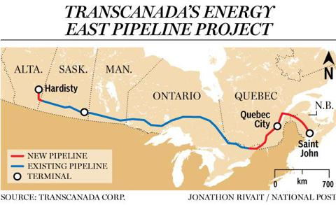
Enbridge's Line 9 Reversal
Line 9 is an existing Enbridge 762 mm (30-inch) diameter pipeline with a current capacity of approximately 240,000 barrels per day (bpd), extending from Sarnia, Ontario to Montreal, Quebec. Currently, the pipeline transports crude oil from areas such as the North Sea, West Africa and the Middle East, in a westbound direction.
The scope of the proposed Project includes reversing the flow of the 639 km-long section of Line 9 from North Westover to Montreal (Line 9B) mainly by modifying existing facilities (please see map for details).
The open season confirmed additional demand to ship crude oil -- mainly light crude oil -- on the reversed pipeline from what had been originally anticipated. As a result, we now propose to expand the capacity of Line 9B from 240,000 bpd to 300,000 bpd. 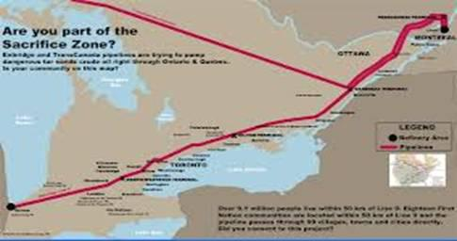
(click to enlarge)
The Keystone XL delay has is also leading to some other ideas that are in an early stage, but could be significant:
Pipeline To The Northwest Territories (Tuktoyaktuk)
The Alberta government says it is in "serious talks" with the Northwest Territories to build an oil pipeline connecting the oil sands to the northern hamlet of Tuktoyaktuk, near the Beaufort Sea.
The Northwest Territories is set to manage its own natural resources by 2014, and the region needs pipelines in place to improve the likelihood that it's own significant resource base will get developed.
There is already a right of way in place for an existing pipeline, and the Northwest Territories Government is very friendly to development.
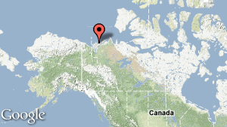
Rail To Valdez Oil Terminal in Alaska
The Valdez oil terminal is actually the closest shipping point to Asia in North America.
Vancouver-based G7G Ltd. (Generating for Seven Generations) is proposing a 2,400-kilometre-long railway running northwest from Fort McMurray, Alta. to the Trans-Alaska Pipeline at Delta Junction, which currently ships oil from the state's dwindling North Slope oil fields to the Valdez super-tanker terminal.
G7G says it has the backing of Canadian First Nations and Alaskan tribes and has conducted a $6-million study on the rail link.
(click to enlarge)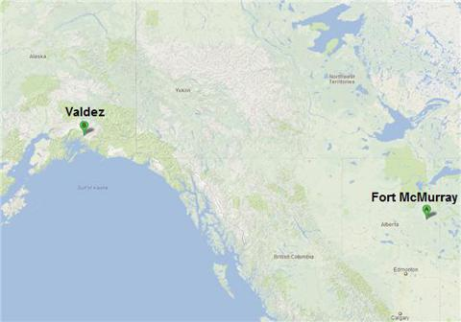
Kitimat Refinery
Canadian billionaire newspaper magnate Conrad Black is spearheading a massive $25 billion refinery project for Canada's West Coast in Kitimat.
The project's website describes the venture as follows:
The project will include a state-of-the-art world scale oil refinery at Kitimat. It may also include a pipeline between Edmonton and Kitimat, a marine terminal, and a fleet of tankers for the refined fuels. The total cost could amount to $25 billion. It will be the largest investment in BC in the history of the province. It will also provide far more permanent jobs than any other investment has done and generate very large tax revenues for the government.
If this project goes forward, it will undoubtedly include a pipeline to get oil from Alberta that otherwise wouldn't exist.
I think Canada is finally starting to get the message that having only one customer for your product isn't great. Additionally, having one customer whose demand for your product is stagnant and is also growing its own supply is really not great.
Canada needs to position itself so that its oil can get to the growing markets for oil like China and India. The longer the Keystone XL is delayed, the better, in my opinion, because that is going expedite the process of Canada securing other options.
This further delay of the Keystone XL only strengthens the wake-up call Canada was needing, and makes this other options more immediately important.
As a shareholder of Canadian oil producers, I'm willing to endure some short-term pain caused by the Keystone delay in exchange for the long-term gain of being able to get the oil to Asia.

1.5.2013
If The Keystone XL Is Rejected, Canadian National Railway Will Benefit The Most
TransCanada's (TRP) Keystone XL pipeline has been the subject of much public debate for years now as proponents and opponents trade arguments over the merits of the pipeline. As designed, the pipeline will stretch 1,179 miles from Northern Alberta to Steele City, Neb., where it will connect with the Keystone pipeline and continue down to the Gulf Coast. If approved, the 36-inch pipeline will carry up to 830,000 barrels per day of bitumen, heavy, tar-like oil. The second leg of the pipeline, from Cushing, Okla., to the Gulf Coast was previously approved and is currently under construction.
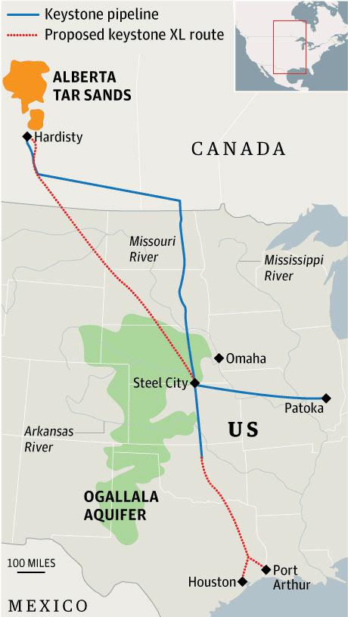
Because the pipeline crosses an international border, it must be approved by the State Department before construction can begin. The president has indicated he will make a final decision on the pipeline by the end of summer. It appeared approval of the pipeline had gained some momentum after the State Department completed an environmental impact study that showed the pipeline would have little environmental impact, and the state of Nebraska, which had objected to the original route of the pipeline, gave approval to the new proposed route. However, last Tuesday the Environmental Protection Agency released a report criticizing the State Department's environmental study and called for a delay in approval of the project to allow for another environmental impact study to be conducted. The EPA report has given ammunition to those who would like to see the pipeline delayed and/or rejected.
I personally do not know if the president will approve or reject the pipeline. At best, I think it is 50/50 that the pipeline is approved. However, I do believe that if the pipeline is rejected, there is one publicly traded company that will benefit the most from the fallout. That company is Canadian National Railroad (CNI).
As I stated in an article I wrote in February, CNI owns the best track system in North America as it is the only railroad that has tracks that cross the continent from east to west and north to south. However, in reference to oil sands, the key track it owns is the track that runs to the oil sands region of Alberta. Below are two maps -- the first map shows the oil sands region located near Fort McMurray and the second map shows the Canadian National rail network, including a closeup of the CNI lines in the oil sands region. As you can see, CNI has lines that run right into the heart of the oil sands region, something no other rail line has. It is my belief that if the Keystone XL pipeline is delayed or rejected, CNI will benefit greatly by being able to provide "crude by rail" service to the oil sands producers.
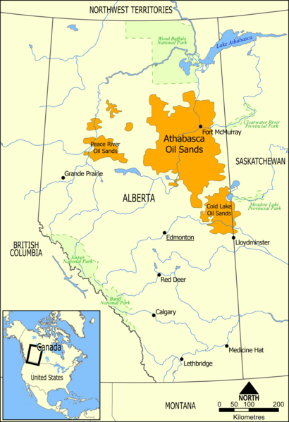
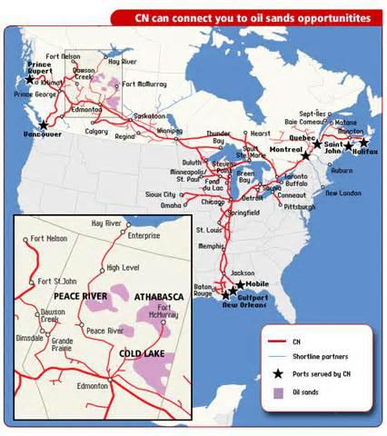
CNI has already seen benefits from the oil sands production. Below are some quotes from CNI management during the recent first-quarter conference call:
Petroleum and chemical, the revenue was up 16% on only a 3% carload growth. Crude by rail revenue was up 300%, and we now have roughly $75 million of our book of business in the first quarter, which was directly crude. As you know by now, crude is a very long haul business for CN, and we at CN are directly serving single-line the U.S. Gulf and all of the Eastern Canada refineries.
On the merchandise side from an outlook point of view, we expect solid growth -- solid revenue ton-mile growth from our crude by rail. CN's story in rail in crude is a story of revenue ton-mile. We expect new crude loading terminal to open on our line in the coming months. Rail complements pipeline. In fact, CN and pipeline companies cooperate where it makes sense.
Also, from a point of view of the refiners, the refiners today are still extremely bullish on leasing cars, buying cars, doing backstop capital investments for those who are willing to build a terminal for the product to move. And they're still very much of the view that getting product by rail allows them to get a price that they can't get from a pipe. So we're still very positive on -- well, not still. We are very positive on crude by rail. A number of people around us are also very positive; the refiners investing into fleet, you see pipeline companies getting interested in doing multimodal with the railroad and themself investing in some terminal to load. A number of people in the U.S. Gulf and our CN line are investing into receiving facilities. More and more players are looking at going the way of unit trains. So this is just still picking up momentum from one quarter to another. And the capital investment by all these different players is very encouraging.
As you can see from the above quotes, CNI management is very high on their "crude by rail" future. One of the reasons CNI loves moving oil/bitumen is the product is long haul, the most profitable for railroads. Much of the product is carried by CNI from Canada all the way down to Mobile, Ala. Although there is much to like about CNI's crude hauling future, there is still much infrastructure to build, purchase, and/or contract for.
Rail Cars: To transport bitumen through pipeline, a diluent has to be added to allow the heavy oil to flow through the pipeline. The same is true of rail cars, unless you purchase specially designed rail cars that can heat the bitumen once you reach your destination point. Using rail cars that heat the bitumen saves the producers money by eliminating the need for the diluent. Crude tanker cars are in high demand and the cost for the specially designed cars is high. Not all the cost falls on the railroads as in many cases producers and terminal operators purchase cars for use.
Loading Facilities: Once the producers harvest the heavy oil, special loading facilities have to be built to load the heavy oil onto the trains. Currently, Canadian National has, or will soon have, access to 10 of these facilities. Like railcars, the expense for the facilities does not always fall on the railroad. Facilities are often operated by the producers, by pipeline companies, and in some cases there are joint ownership operations. The best loading facilities are unit train loading terminals; however, few of those are currently in operation.
Refinery Destinations: This is where the Canadian National rail network, which I showed above, shows its advantage over Canadian Pacific (CP). CNI has the advantage of loading the bitumen onto its railroad and delivering it directly to various Gulf Coast refineries. The CP network (shown below) does not have that ability; thus it would have to enter into agreements with other railroads to get the product to the refineries that can handle the heavy crude, most of which are on the Gulf Coast.
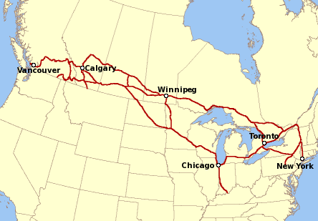
CNI, in partnership with Arc Terminals, is currently building a tank car unloading facility in Mobile, Ala. The facility when completed will handle 40 tank cars a day, with the ability to expand as demand increases. Each tank car can hold approximately 600 barrels of heavy crude. Arc Terminals President John Blanchard said the following concerning the facility:
'The rail transload terminal will … provide Canadian producers single-haul service to our Mobile destination,' he said. 'A single-line haul is more efficient and less expensive than those involving two or more rail carriers and multiple terminal switching.'
CNI also signed an agreement in March to move crude through the LBC Tank Sunshine terminal in Geismar, La. No other railroad can offer that single line haul service from the oil sands region.
The Potential: Andrew Potter, analyst at CIBC World Markets, said he expects production from the oil sands of northern Alberta, the world's third biggest crude resource, to jump 2 million to 2.5 billion barrels a day by 2020 from 2011's output of 1.6 million bpd. Potter believes oil sands from production from both mining and steam could jump to 4.1 million barrels a day in eight years. Knowing that Exxon Mobil's (XOM) Kearl Oil Sands project is just beginning production and will eventually be processing 350,000 barrels a day and other major producers are still ramping up their production, I believe that forecast will be relatively accurate.
What About Other Pipelines? Besides the Keystone XL pipeline that would carry 830,000 barrels a day, Kinder Morgan (KMI) plans an expansion of its Trans Mountain pipeline from 300,000 barrels a day to 890,000 barrels per day, and Enbridge (ENB) has proposed the Northern Gateway pipeline, which would carry 525,000 barrels a day of bitumen to the coast of British Columbia. Enbridge has also applied to reverse a pipeline that runs to the East Coast and would carry 300,000 barrels a day. If all these pipelines get built, that is additional capacity of over 2 million barrels a day, far short of what will be needed to carry all of the oil sands potential production. In addition, none of the pipelines have even started construction. The Northern Gateway pipeline is facing stiff opposition from a number of groups and may not get built. Kinder Morgan's Trans Mountain proposal is in the first year of a two-year approval process and would not be complete until 2017. Enbridge's other proposed pipeline reversal to the east coast is a relatively new proposal and is also years away.
Rail Best Alternative: So if President Obama rejects the Keystone XL, it is clear to me that CNI may be asked to haul quite a bit of oil. Even if it is approved, TransCanada has stated it would not go into operation until the second half of 2015. Even if all the pipelines are built, I do not believe there is enough overall capacity to move all the oil without railroad participation. There are many deep pocket producers in the Athabasca oil sands region, including Exxon Mobil, Royal Dutch Shell (RDS.A), Suncor (SU), ConocoPhillips (COP), and Total (TOT), to name a few. These producers will not stop production after having sunk in billions of dollars developing the area because the Keystone XL is rejected. The crude will be moved and will be moved by rail if necessary.
Final Thesis: I believe CNI will benefit from the continued build out of the oil sands production in Canada and will benefit even more if the Keystone XL is rejected. CNI's one-of-a-kind rail system will allow CNI to provide one-line service from the oil sands region to the various heavy crude refineries, and will also allow CNI to bring various supplies into the oil sands region for the producers. The increase in crude by rail service will be substantial and will be accretive to earnings.
The crude by rail business will not increase exponentially overnight, but rather slowly and steadily over years. Investors with a long-term horizon should benefit from the growing earnings and will be additionally rewarded from CNI's growing dividend.

1.5.2013
Canadian National Railway
Land: Kanada  Währung: CAD  Branche: Transportwesen  Website: http://www.cn.ca  ISIN: CA1363751027  Börsenplatz: Toronto | Aktuelle Zahlen vom 29. April  Kurs: 97.900  Dividendenrendite: 1.53% L  KGV: 16.0
Auszahlungsfrequenz: quartalsweise  Auszahlungsmonat(e): März Juni September Dezember | Nächste Auszahlung: -  Hauptversammlung:  (Generalversammlung)
Geschäftsjahr (Abschl.Dezember)  Gewinn pro Aktie  Dividende pro Aktie  Veränderung zu Vorjahr  Sonderdividende  Dividendenrendite Höchst  Dividendenrendite Tiefst  Ausschüttungsquote | 2012  6.120  1.500  15.4%  2.0%  1.6%  25% | 2011  5.410  1.300  20.4%  2.0%  1.6%  24% | 2010  4.480  1.080  6.9%  2.0%  1.6%  24% | 2009  3.920  1.010  9.8%  2.7%  1.7%  26% | 2008  3.950  0.920  9.5%  2.3%  1.6%  23% | 2007  4.250  0.840  29.2%  1.8%  1.4%  20%
Legende:
nk = nicht kalkulierbar

1.5.2013
Dividend Reinvestment Calculator updated May 01, 2013

Formularbeginn
Enter Any Stock Symbol:
Select Start Date: | 1.1.1997
Select End Date: | 1.5.2013
Annualized Total Return: | 20.79%
$1000 Invested Is Now Worth: | $20,119.10
Earliest Stock Data Found: | November 26, 1996

Formularende

Historical Annual Dividend Payout updated May 01, 2013

Formularbeginn
Enter Any Stock Symbol:

Formularende

Annualized Dividend Growth Rates
5 Years | 10 Years | 25 Years
13.74% | 17.95% | 0%

