15.12.2012
Einfluß von Wechselkursen!
Zum 1.1. kostet 1 € = 1,5$. ( Euro ist stark geworden, Dollar ist schwach geworden)
Eine Aktie kostet 3 $ = 2 €
Zum 31.12. kostet 1€ = 1,2 $ ( Euro ist schwach geworden, Dollar ist stark geworden)
Eine Aktie kostet 3,6$ = 20 % Kursgewinn
3,6 $ sind aber 3 €.
In Euro gerechnet habe ich 50 % Kursgewinn ( 2 Euro invest, 3 Euro zurück)

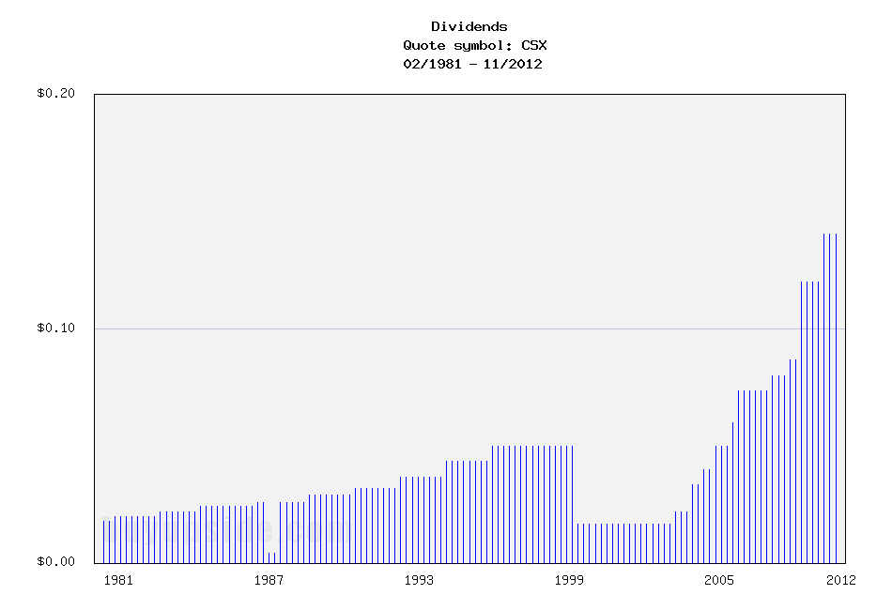
CSX Corporation (CSX)
CSX Corporation (NYSE: CSX) operates a large railroad system that serves most of the eastern United States.
-Seven Year Revenue Growth Rate: 4.6%
-Seven Year EPS Growth Rate: 11.4%
-Seven Year Dividend Growth Rate: 33.1%
-Current Dividend Yield: 2.85%
-Balance Sheet Strength: Leveraged, Fair

Overview
CSX Corporation is a large railroad company with over 21,000 miles of track in 23 states. The company had a period of poor management and performance, but in the last several years has rebounded to become a strong performer as a Class I railroad. According to the company's Baird's Industrial conference presentation, the revenue breakdown for CSX so far in 2012 was as follows:
General Merchandise
General merchandise is the largest segment, accounting for 41% of total revenue. This is further divided into Automotive, Metals, Chemicals, Phosphates, Agriculture, Food and Consumer, Forest, and Exports.
Coal
Coal is a large individual component of revenue, with 14% of total revenue coming from domestic coal transport, and 7% of total revenue coming from export coal transport, for a total of 21%. Domestic coal is facing strong headwinds currently.
Intermodal
For CSX, 38% of revenue came from intermodal shipping.

Ratios
Price to Earnings: 11
Price to Free Cash Flow: 40
Price to Book: 2.3
Return on Equity: 22%

Revenue
(click to enlarge)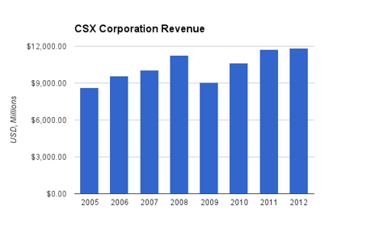
(Chart Source: DividendMonk.com)
For both of these charts, the 2012 figures actually refer to the trailing twelve months, which include the last 3 months of 2011 and the first 9 months of 2012.
Revenue over this period grew at an average rate of 4.6% per year, but the growth was erratic due to the large hit the company took during the recession.

Earnings and Dividends
(click to enlarge)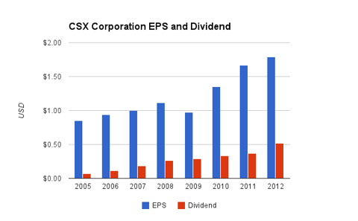
(Chart Source: DividendMonk.com)
Earnings growth over this period was substantial, at 11.4% per year. A significant portion of this was due to stock buybacks.
The dividend currently yields 2.85% with a low earnings payout ratio. Free cash flow is very low in the trailing twelve month period and barely covers the dividend, but this is due to a combination of capital expenditures above their long-term baseline, and a recent moderate reduction in operating cash flow due to reductions in coal transport volume. So overall, their dividend appears quite safe going forward.
The dividend has grown at a 30+% annualized rate over the last several years, but this was partially due to an expanding payout ratio. The company targets a 30-35% payout ratio, which is where it's currently at, so the future dividend growth should be roughly in line with EPS growth.
Approximate historical dividend yield at beginning of each year:
Year | Yield | Payout Ratio
Current | 2.85% | 31%
2012 | 2.1% | 29%
2011 | 1.5% | 22%
2010 | 1.7% | 24%
2009 | 2.5% | 31%
2008 | 1.5% | 23%
2007 | 1.5% | 20%
2006 | 2.1% | 12%
2005 | 2.0% | 14%
How Does CSX Spend Its Cash?
The company lists its three priorities, in order, as:
Capital Investment- CSX expects to invest 16-17% of revenue into core capital investment.
Dividends- CSX expects to pay out 30-35% of TTM earnings as dividends.
Share Repurchases- The company is finishing up a $2 billion share repurchase program with plans for a new one.
During the fiscal years 2009, 2010, and 2011, the company brought in over $3.2 in free cash flow. Over this same period, $1.2 billion was paid out as dividends and $3 billion was spent to buy back shares and reduce the share count. The number of shares peaked at nearly 1.4 billion shares in 2006, but has since decreased to around 1.05 billion, because the company spent over $7 billion buying back stock. As a reference, the market cap is currently around $20 billion. No cash was spent on acquisitions.

Balance Sheet
The total debt/equity ratio of CSX is slightly over 100%. Total debt/income is a bit under 5x. The debt has been increasing over the last several years from approximately $5 billion to $9 billion. There is negligible goodwill.
The interest coverage ratio is a bit over 6x, which is on the low side, but stable. Overall, the balance sheet has some leverage, but remains stable, and is in fair condition.

Investment Thesis
This is a sister article to the recent report on Norfolk Southern (NSC). Both of these companies operate railroads with nearly identical geographic locations, have nearly identical market capitalizations and stock valuations, have similar balance sheets, have similar priorities of capital investment, dividends, and buybacks, and they both recently took a cash flow and stock price hit from a reduction in coal volume (which is due to their nearly identical geographic footprint).
From an investor's perspective, these are very similar equities, so it's worth highlighting some subtle differences:
Norfolk Southern
-Higher dividend yield of 3.32%
-Slightly stronger balance sheet
-Slightly smaller rail network, with less extension north and south across the eastern coast
-Consistently strong operating performance
-Has slightly more exposure to coal, which is a major headwind currently
CSX Corporation
-Lower dividend yield of 2.85%
-Slightly weaker balance sheet
-Slightly larger rail network, with more extension north and south across the eastern coast
-Had poor financial management years ago, but has rebounded with strong performance
-Has slightly less exposure to coal, which is a major headwind currently
Between the two, I consider Norfolk to be a slightly more resilient dividend stock, while CSX is possibly a bit more of a value play. In general, the market appears to be treating these two businesses very efficiently with the same stock valuation.

Risks
The volume and revenue of a railroad company is highly dependent on the economy. Weak macroeconomic conditions mean less freight is shipped. Since railroads have substantial fixed operating costs, a decrease in volume and revenue results in an amplified decrease in earnings and free cash flow.
CSX and competitor Norfolk Southern have very similar overlapping rail networks over the eastern half of the United States. This will keep pricing rather competitive and efficient.
The company recently took a hit from decreases in coal volume. Coal is being used less in the region for electricity generation, so their domestic coal shipments have a strong headwind that likely isn't going away soon due to the efficiency of natural gas. The rest of the segments of CSX will have to carry the coal segment and the overall company forward.

Conclusion and Valuation
The company is capable of moving 1 ton of freight 500 miles on one gallon of fuel, which is three times more efficient than trucking. Railroad companies have competitors, but due to the literally entrenched position of their assets, rail companies have some economic advantages as long as the capital is managed well and as long as economic conditions remain viable.
Unless free cash flow picks up substantially, the share buybacks will have to slow down, because the company has been leveraging their balance sheet in a low interest rate environment to reduce the share count and accelerate EPS and dividend growth.
If the operating cash flow rebounds a bit from the recent drop, up to $3.3-$3.4 billion or so, and if the company invests 16-17% of revenue into capital projects as planned, then that leaves around $1.3-$1.4 billion for dividends and buybacks, which is around 7% of the current market cap. As the shareholder yield, that's roughly the return that an investor would receive with no growth. If 3-4% revenue growth is estimated, based largely on inflation and mild volume increases, then the company is in a position to provide a good rate of return.
Using the Dividend Discount Model with a 10% discount rate as a target rate of return, the company is currently fairly valued at a price of just under $20 based on the estimate of 7% long-term annualized dividend growth (4% from buybacks, 3% from top line growth). If the dividend growth rate is estimated to be 8% instead, then the fair value jumps to nearly $30 for the same discount rate.
I believe that the current stock price of CSX of just under $20 is fairly valued or moderately undervalued, just like Norfolk Southern. In addition, if investors are bullish about the fundamentals of the company over the long-term, but want to enter the stock with a lower cost basis to increase the margin of safety, then selling January 2014 puts at a strike price of $20 can result in a 13-14% annualized rate of return if the option is not exercised, or entering the stock with a cost basis of under $17.50 if the option is exercised.
15.12.2012
CSX Corporation (CSX)
The Class I operators in the United States appear to be reasonably valued for long-term returns. The balance sheets are in solid condition, they all have competitive advantages against new competitors entering the market, and some of them pay decent dividend yields.

The Rail Renaissance
Ever since the 1980s when deregulation allowed the rail companies to operate more profitability, railroad stocks in general have enjoyed market-beating returns. Improved automation technologies, increasing congestion of highways (which haven't kept up with increases in car and truck traffic since the construction was initiated under President Eisenhower), and changes in energy costs (railroads are far more efficient with fuel than trucks are), have allowed railroads to improve their operating margins over time.
Investors have different approaches to stocks that have performed well. Some investors believe that buying stocks in an uptrend is a smart buying approach, while other investors believe the exact opposite, and instead look to enter positions after big setbacks.
A more fundamental approach is to ignore previous stock movements, and simply focus on the question of whether the current price is fundamentally undervalued, fairly valued, or overvalued compared to the intrinsic value calculated by estimates of forward-looking performance.
Despite the fact that many of these railroad stocks have already outperformed, some of the most-followed value investors that buy with very long-term horizons are the biggest owners in these companies. Bill Gates, and more specifically through his value-investing chief investment officer Michael Larson, is the largest shareholder of Canadian National Railway (CNI). Warren Buffett took it a step further and acquired the entirety of the Burlington Northern Sante Fe railroad in 2010, and this was his largest acquisition ever.
Based on valuation methods such as the Dividend Discount Model, many of these stocks appear poised to offer returns in the low double-digit range.

Returns Come Mostly From Shareholder Yield, Not Growth
One thing all of the railroad companies have in common is that they are using their free cash flow to buy back their own shares in large numbers and pay moderate-yielding dividends.
The shareholder yield of a stock is the sum of dividends and share buybacks divided by market capitalization.
In other words, if a company pays a 3% yield and buys back 4% of its shares each year (net of shares issued), then the shareholder yield is 7%. That's essentially the expected long-term rate of return the investor gets when 0% core growth is expected. When there is growth, it is on top of the shareholder yield, and the shareholder yield is the internal rate of return the company can keep giving shareholders as long as it has stable free cash flows. If the railroad can boost actual volume by 1-2% per year over the long-term (they've been going a lot faster than that lately, but it's part of a rebound and won't continue indefinitely), and then maintain pricing power of 2-3% increase per year (or in line with whatever the inflation rate is over the period), then another 3-5% rate of return is added onto the shareholder yield.
Investing for the long-term in these railroad stocks, in other words, is basically a bet or estimate that they won't decline in business. As long as they perform flatly, or have 1-2% growth and maintain pricing power, returns can be in the high single digits or low double digits over the next decade. There won't be tremendous growth as there was over the last 25 years, but the industry appears to be a good one to put some capital. The companies can just keep chugging along, reducing the share count and raising their dividends, so that long-term investors can own larger and larger portions of the company and increase the yield on cost.

Risks that Could Threaten the Industry
Authors of articles such as this, this, this, and this (in chronological order), have voiced concerns over the risk that high-speed passenger lines, desired by the federal government, may harm freight railroad companies, or at least show the involvement government has to have with these freight lines in order to proceed.
During the unprofitable period of regulation of railroad stocks, the companies had to serve places that were not profitable to serve. The government proponents of high speed rail currently have to work with the freight companies to use some of their infrastructure, which can impact the efficiency of freight shipping.
It's not a sure-fire problem. With proper planning, passenger trains and freight rail can coexist profitably. Nonetheless, it remains a risk for the industry.
If you like the fundamentals of the industry but want to increase your margin of safety and enter positions with a lower cost basis, selling put options can reduce the cost basis by 10% or so.

How to Play It
The Class I railroads in the United States are Norfolk Southern (NSC), CSX Corporation (CSX), BNSF (owned by BRK.B BRK.A), Union Pacific (UNP), and Canadian National Railway (CNI).
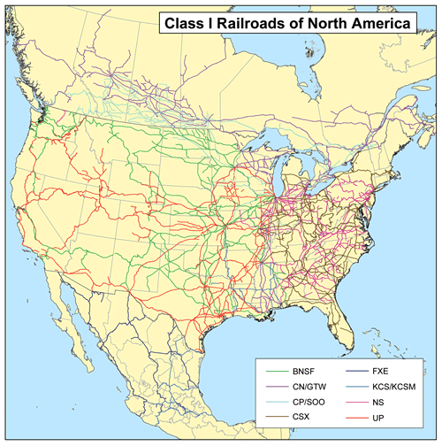
Focusing on the U.S. rail lines, the railroad stocks are divided into two or three groups.
Eastern Group
The eastern group consists of CSX Corporation and Norfolk Southern. They share very similar geographic positions across the eastern half of the United States. What you'll see if you look at the stock price history is that they both took large recent stock price hits (especially NSC), because their coal volumes dropped substantially.There appears to be a long-term trend of natural gas replacing coal for electricity generation, and since three out of the top five states for coal production are in the eastern third of the country, these rail lines have a disproportionate share.
These two companies are also a bit more leveraged than their western counterparts. They took on a bit more debt to buy back shares more aggressively. Still, since they don't have goodwill from acquisitions and their interest coverage ratios are comfortable, their balance sheets are fair.
The coal headwind and the slightly more leveraged positions have resulted in earnings multiples of only around 11 for both of these companies. These two can be considered the "value plays" out of the five companies.
A decent play to add or increase exposure to railroad stocks is to diversify across an eastern and a western railroad, or CNI and one of the eastern or western railroads.
Here's an overview of the current dividends of each stock:
Company | Yield | Payout Ratio
BNSF (Berkshire Hathaway) | 0% | 0%
Canadian National Railway | 1.65% | 25%
Union Pacific Corporation | 2.23% | 34%
CSX Corporation | 2.81% | 31%
Norfolk Southern | 3.25% | 36%
16.12.2102
Adding CSX - An Undervalued Dividend Paying Stock
The Basic Fundamentals
As with all of our core holdings, I like to own big companies that pay us to own their shares. I also want the company to have a strong track record of growing revenues and earnings. CSX has that plus plenty more.

The dividend yield is approaching 3% (an accidental high yielder perhaps?). Revenues are growing, earnings are growing, and cash from all operations are growing. The only metric that has dipped recently is the share price.
Here are some additional fast facts:
- Dividends have been increased by 300% since 2008.
- The payout ratio is only 29%.
- Nearly 70% of all outstanding shares are held by institutions.
- A below average P/E ratio of 10.35.
- An ESS (Starmine) rating of BULLISH.
- A share price selling near 52 week lows.
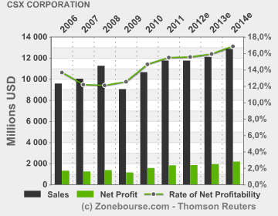
This chart shows the trend of both earnings and revenues, as well as the estimated trend through 2014. I do understand that CSX relies heavily on a growing economy and I believe that as the economy grows faster, so will CSX.
As CSX grows, I also believe that they will continue increasing their dividends. With a 29% payout ratio, the company can certainly afford to maintain their dividend as well as increase them even now. When the economy grows, and earnings and revenues of CSX grows, that payout ratio should drop further, giving the company even greater flexibility to returning shareholder value.
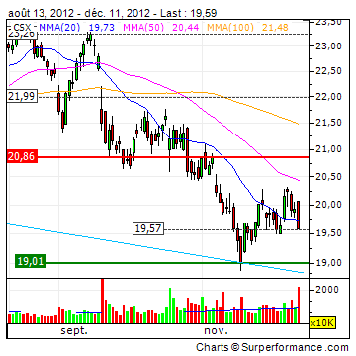
As you can see in this chart, the stock has taken a hit since August. Buy the dips, add to the core, and catch a better dividend yield. CSX is not going away and the company has a very strong balance sheet.
Yes, they had a down quarter recently, but the company should bounce back as the economy does. For now, the dip is our buy signal.
16.12.2012
CSX: Long-Term Growth Prospects And Attractive Valuation Make It A Buy
Warren Buffett has stated his favorite holding period for a stock is "forever." This is in stark contrast to stock and fund salesmen who utilize slogans such as "buy and hold is dead." The most important determinant of an investment is the price that is paid in relation to the value one receives. If an investor can buy a business at a cheap price that is likely to earn higher returns on invested capital than its cost of capital over a long-term time horizon, then a buy and hold strategy can make a lot of sense. Right now few industries are struggling more than the domestic coal market, as historically low natural gas prices are diverting domestic utility demand away from coal.We are using the weakness in domestic coal to build long-term positions in the railroad industry, which we believe to be undervalued and likely to provide attractive long-term total returns at current prices.
Coal has long been a huge market for the railroad industry, particularly for the East Coast operators such as CSX Corporation (CSX) and Norfolk Southern (NSC). We currently find both stocks quite attractive but for this article we are going to focus on CSX. Historically around 32% of consolidated revenue for CSX has been related to coal. While I believe that the economics of natural gas have fundamentally changed the outlook for coal, particularly in the utility space, I also believe that new uses for natural gas in addition to the potential for a strong LNG export market could ultimately lead to higher prices for the commodity. Global energy needs are complex and evolving. Coal exports are up and likely to continue to increase even if domestic consumption is down the next year or two. Coal will still be needed but overall too much focus is put on this one portion of the railroad revenue model.
(click to enlarge)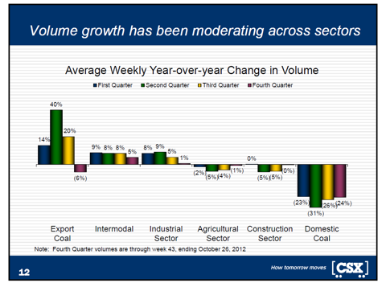
CSX Corporate Presentation
Since de-regulation the railroad industry's economics have changed dramatically for the better. Few companies have improved their operations more than CSX, which had historically been one of the real laggards in the industry. Since 2003-2011 operating income has increased at a compound annual growth rate of 19%, from $861MM to $3.418 billion. The Operating margin has jumped from 11% to 29%, while earnings per share have increased from $0.26 to $1.67 over the same time period.
(click to enlarge)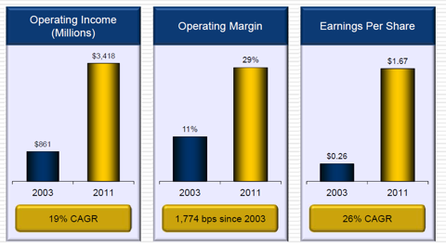
CSX Corporate Presentation
Between 2006-2011, CSX has returned $9.1 billion to investors via dividends and stock buybacks, while still spending $10.6 billion on capital investment. In 2012, the company will likely have hit its target of $2.25 billion in capital investment and most likely will have finished the final part of its $2 billion stock buyback program. Because CSX is generating strong free cash flows, I'd fully expect to see another large buyback program announced, which at current prices would be highly accretive to long-term shareholders. CSX generally reinvests 16-17% of revenue into capital, but fortunately for the industry the economics are somewhat similar in that the companies are generally able to achieve a reasonable return on these large and regular investments. CSX has increased its quarterly dividend ten times since 2005 and the company targets a dividend payout of 30-35% of TTM earnings per share. In the 2nd quarter of 2012 the dividend was increased by 17%, and management has forecasted that another possible increase may be announced next May.
The beauty of the railroad industry is that the assets are the definition of long-term and really are irreplaceable. I may not be able to forecast what cell phone will be the most popular device 10-years from now, but I'd bet that CSX' tracks will be busy transporting increasing amounts of goods across the United States, and that pricing should improve at a rate slightly higher than rail inflation costs. Highway congestion continues to get worse and fuel prices are increasingly enhancing the competitive advantages of rail versus long-freight trucking. CSX railroads are centered on the eastern United States and serves roughly two thirds of the U.S. population. The network spans from south Florida to the Northeast United States where the majority of consumption and high-density population centers are.
(click to enlarge)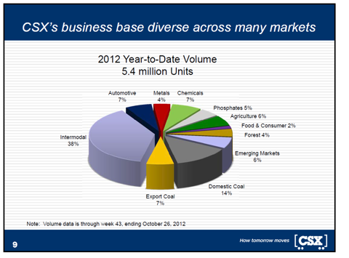
CSX Corporate Presentation
(click to enlarge)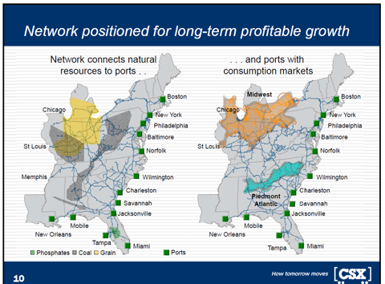
CSX Corporate Presentation
Because CSX connects many ports to the major cities it continues to win business, particularly in intermodal transportation. CSX can take containers to and from the ports to the large population centers and it seems likely that international growth can be a huge benefit for the company. CSX also enters into partnerships with trucking companies where it takes goods part of the way, while the trucking companies handle the short-haul final delivery phase. An improving housing sector, which is likely to see increased homebuilding due to a dearth of available new homes, should slightly offset the headwinds in coal as well. Agriculture and phosphates transportation should continue to be strong markets over the long-term. Over the next 5 years it seems likely we'll enter at least one recession, and current GDP growth is anemic at best.
(click to enlarge)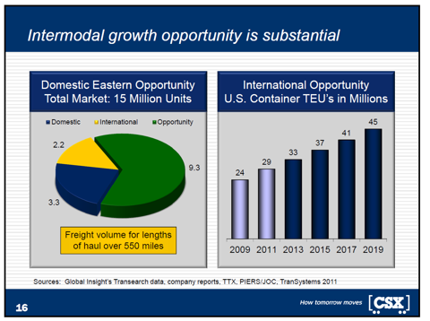
CSX Corporate Presentation
Investing in the railroad industry is a long-term bet that things will get better in the United States and I'm very confident that this will indeed be the case. When Warren Buffett established Berkshire Hathaway's (BRK.A) (BRK.B) ownership of Burlington Northern Santa Fe, he was extremely patient and price disciplined. If I recall correctly, I believe that he used put options at one point to establish a cheaper entry price into the stock. I believe that an investor in CSX would be well-served to use a similar tact, and to really focus on dollar cost averaging. While the current price is very cheap, if we have a recession it could get cheaper so you want to plan for that before you first start buying the stock. Selling puts is a great way to manufacture pricing discipline in that the investor will either generate income, or get into the stock at a more attractive price.
CSX' 3rd quarter results were decent with revenue down 2% to $2.894 billion, largely because of the decrease in domestic coal. Operating income was down about 3% YoY to $854MM. Net earnings were down 2% to $455MM. I like that the company has bought back stock and I'd prefer a heavier weighting towards buybacks at current prices, as opposed to the large dividend payout. Buybacks make more sense for the railroad industry because they can be done with sensitivity to price, and they are less permanent than dividends so companies can adjust as needed to reduce expensive debt, or increase capital investments when opportunities are attractive. After the 3rd quarter the share count was down to 1.040 billion, and earnings per share for the quarter were $0.44, up 2% YoY. CSX had done a great job at improving the operating ratio, which now sits at 70.5%. The 2015 goal is to get that number down to 65%, but this might be overly optimistic with the difficulties in coal.

At a recent price of $19.95, CSX has a market capitalization of roughly $20.75 billion. I believe in a more buoyant economy, CSX has the potential to earn more than $2 billion in net income. The stock trades at just under 10 times forward earnings, but those earnings estimates might be a bit high for 2013. The company has a return on invested capital greater than 10% and a return on equity greater than 20% over the last twelve months. The company has not consistently generated such high returns so a regression to the mean is possible, particularly in a recession. The stock yields roughly 2.7% and I believe the dividend should grow steadily, as will stock buybacks. I believe that CSX is worth roughly $30 per share looking 3 years out.
21.12.2012
2 Cheap Railroad Stocks To Buy For 2013
Overview
As part of the volatile transportation sector, railroad stocks can sometimes be overlooked as potentially compelling investments. Rail stocks are sensitive to changes in fuel prices, as well as to fluctuations in freight prices. The US stocks recommended in this article are cheaper than their Canadian counterparts such as Canadian Pacific (CP) and Canadian National Railway (CNI), which trade at 17.5x and 14.7x 2013 earnings estimates, respectively. The companies below have market caps of at least $19 Billion, have dividend yields of at least 2.9% and trade for less than 11x 2013 earnings estimates.
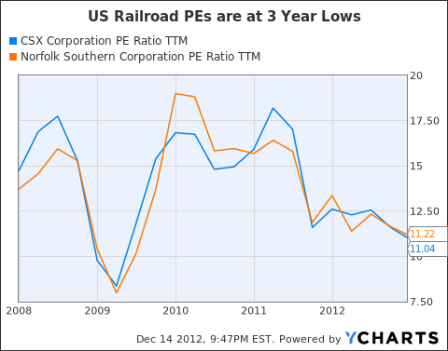
CSX (CSX)
Market Cap: $20 Billion
Dividend Yield: 2.9%
Estimated 2013 PE Multiple: 10.5x

CSX, one of the country's largest railroad companies, is down more than 7% over the past year. The company operates approximately 21,000 miles of rail track in 23 US states, Washington DC and two Canadian Provinces. Over the years 2003 to 2011, CSX was able to increase EPS at a CAGR of 26%. Additionally, during this period, CSX was able to improve operating margins by 1,774 BPS. Although, the company has suffered some volume losses recently, CSX was still able to increase EPS in Q3 2012 by slightly more than 2% YoY partly due to its stringent cost cutting measures. In addition to its 2.9% dividend yield, CSX is also undertaking a fairly large share buyback program.
27.12.2012
Coal Producers - Other than the gas producers themselves, no one would be helped more by actions which increase natural gas prices than coal producers. As I have written before, coal is under pressure from natural gas in its most important market - electric utilities. The market is likely to see positive prospects for natural gas exports as a big plus for coal stocks.
Gasexport ->höhererGaspreis ->bessereKonkurrenzfähigkeit der Kohle ->mehrKohlefracht.
27. Dezember 2012, 14:46 Uhr

Kanalerweiterung

Panama-Flutwelle trifft deutsche Häfen
Kommentar: Der neue Panamakanal ist gut für NSC, da diese Linie die Häfen an der „richtigen“ Seite der USA haben.
Von Markus Gärtner
In einem Jahr wird die Erweiterung des Panama-Kanals für Megafrachter abgeschlossen. Der Gewinner steht bereits fest: China. Deutsche Häfen wie Hamburg drohen im Kampf um die Superschiffe leer auszugehen.
Vancouver - Mit der Jahreswende rückt der nächste Meilenstein in der Globalisierung näher. Die Erweiterung des 77 Kilometer langen Panama-Kanals wird in einem Jahr abgeschlossen sein. Der künstliche Wasserweg revolutionierte 1914 mit seiner Fertigstellung den globalen Güterhandel. Er verkürzte den 22.000 Kilometer langen Seeweg von New York nach San Francisco auf 9600 Kilometer, weil die lange Umrundung des südamerikanischen Kontinents seitdem entfällt.
Derzeit wird letzte Hand an die dritte Spur des Kanals angelegt und zwei supergroße Schleusen zu Ende gebaut. Dann können sich die Megaschiffe der Post-Panamax-Klasse durch den Kanal schieben. Sie sind doppelt so groß wie bisher und führen mit 15.000 Containern drei Mal so viel Fracht.
Die Folgen für den Welthandel sind weitreichend und machen Hafendirektoren und Frachtmanager bis nach Hamburg ziemlich nervös. Denn die Post-Panamax-Schiffe machen trotz eines Anteils von erst 16 Prozent der Flotte bereits 45 Prozent der Frachtkapazität auf den Weltmeeren aus. Bis 2030 soll ihr Kapazitätsanteil auf 62 Prozent steigen. Der erweiterte Panama-Kanal wird ein großer Treiber dieser Entwicklung sein.
Von den USA bis nach Europa sind jedoch nur wenige Häfen im Zeitplan mit der nötigen Vertiefung von Hafenbecken und Brückenvergrößerungen, um die rasch wachsende Zahl der Ozeanriesen mit ihrer vollen Last aufzunehmen. Während die Nachzügler in diesem Wettlauf gegen die Uhr kämpfen, reiben sich die großen Gewinner bereits die Hände: Asiens, vor allem Chinas Zugang zu den großen Absatzzentren im Osten der USA wird billiger, schneller und leichter.
Kanalerweiterung hilft US-Industrie
Viel von der Fracht aus Fernost - Spielzeuge, Maschinen, PCs und Elektronik - wird bislang an der Westküste der USA in Häfen wie Los Angeles und Long Beach gelöscht. Dann werden die Container auf LKW gehievt oder auf Eisenbahnen verladen und quer durch die USA zu den Kunden gebracht.
Mit den Ozeanriesen, die künftig den erweiterten Panama-Kanal durchqueren können, ist es weitaus billiger, die Güter gleich in Häfen an der Ostküste zwischen Florida und New York zu bringen. Dort freut man sich, denn das zusätzliche Frachtvolumen mit Asien kann zumindest einen Teil der verlorenen Volumina im Handel mit dem rezessionsgeplagten Europa ausgleichen.
Mehr noch: Der leichtere Zugang für billig verschiffte Massenware und Maschinen wird die Rückverlagerung von Industrie nach Amerika - die vom lokalen Energieboom schon angestoßen wird - noch beschleunigen. Der Renaissance des verarbeitenden Gewerbes in den USA wird das helfen. Nicht über Nacht, aber trotzdem spürbar. Bereits sichtbar ist der neue Trend mit Ansiedlungen von Airbus in Mobile, Boeing in Charleston und Caterpillar in Athens, Georgia.
Und China, Indien und anderen Schwellenländern in Fernost wird die Verbreiterung des Panama-Kanals zusätzliche Handelsvorteile bescheren. Denn Rohstoffe und Agrarprodukte aus Südamerika - von Eisenerz und Sojabohnen aus Brasilien bis hin zu Öl aus Venezuela - werden durch den erweiterten Panama-Kanal ebenfalls einfacher, billiger und schneller nach Fernost transportiert werden können. Chinas massiver Energiegunger wird sich noch besser stillen lassen.
China für mehr Länder wichtigster Handelspartner als USA
Kein Wunder, dass die Chinesen über den reinen Kanal längst hinausdenken. Kolumbiens Präsident Juan Manuel Santos hat preisgegeben, dass seine Regierung Gespräche mit China führt, um einen "trockenen Panama-Kanal" zu bauen. Gemeint ist damit eine 7,6 Milliarden Dollar teure Eisenbahnstrecke durch Kolumbien mit dem Ausbau des Hafens am Ende der Zugverbindung, um der Volksrepublik einen besseren Zugang zu Lateinamerika zu bescheren.
Der vergrößerte Panama-Kanal stellt für China, das seit der Finanzkrise in zahlreichen Ländern der Welt die USA als führenden Handelspartner ablöste, einen weiteren strategischen Coup dar. Waren die USA 2006 noch der wichtigste Handelspartner für 127 Nationen - im Vergleich zu China mit lediglich 70 - so hat sich das Verhältnis seitdem völlig umgekehrt. Jetzt ist die Volksrepublik der wichtigste Handelspartner von 124 Ländern, die USA sind es nur noch für 76.
Aber auch die Schwellenländer auf der westlichen Hälfte Südamerikas können die Erweiterung des Panama-Kanals feiern. Denn auch Chile, Peru und Kolumbien erhalten besseren Zugang zur Ostküste der USA. Selbst im fernen Kanada, dem größten Handelspartner der USA auf dem Doppelkontinent, gibt es Gewinner. In Halifax zum Beispiel kann der Tiefseehafen künftig mehr von den modernen Ozeanriesen mit bis zu 15.000 Containern aufnehmen.
Verlierer aber werden die Häfen an der Westküste der USA sein. Zwei Drittel der Fracht, die im Hafen von Seattle anlandet, wird auf der Schiene in den Mittleren Westen befördert. Vieles davon wird künftig direkt durch den Panama-Kanal an die Ostküste schippern.

CSX hat Atlantichäfen ( gut)
Aufrüstung der Häfen im Osten der USA kommt spät
Vor allem an der Ostküste der USA ist daher fieberhaft die Vorbereitung auf das Zeitalter der Megaschiffe im Gange. Die Häfen im Osten der USA haben ohnehin 2012 zum ersten Mal seit dem Zweiten Weltkrieg den Westhäfen in den Staaten Washington, Oregon und Kalifornien die Tonnage-Führung abgerungen. Das ist einer Studie des Immobiliendienstleisters Colliers International vom August zu entnehmen.
Die Aufrüstung der Häfen im Osten der USA kommt spät, wie viele in der Frachtbranche finden. Während die Westküste dank ihrer tiefen Pazifikhäfen schon lange die neuen Frachtriesen aufnehmen kann, werden bis zur Eröffnung der dritten Spur des Panama-Kanals nur drei Häfen bereit für die Reederei-Riesen des Panama-Kanal-2.0-Zeitalters sein: Baltimore bis 2013, Miami bis 2014 und Norfolk (bereits fertig).New York kämpft noch mit der Vertiefung des Hafenbeckens im Jahr 2013 und vor allem mit der Erhöhung der Bayonne-Brücke, die für eine Milliarde Dollar bis 2016 angehoben werden soll. Die Häfen in Charleston, Jacksonville und Port Everglades wollen bis 2017 ebenfalls ihre Becken auf 50 Fuß vertiefen.
Aber nicht nur Hafendirektoren und Shipping-Magnaten sehen der Fertigstellung des erweiterten Panama-Kanals aufgeregt entgegen. Auch Bauentwickler, Investoren und Supply-Chain-Strategen fiebern dem neuen Zeitalter entgegen. An der gesamten Ostküste der USA - sowie rund um die Häfen am Golf von Mexiko - werden Lagerhäuser, zusätzliche Terminals und Logistikzentren gebaut. "Kapital aus den privaten und öffentlichen Sektoren fließt reichlich in die gesamte Infrastruktur im Großraum der Häfen, es konzentriert sich auf Lagerhallen und Distributionszentren", erklärt John Carver, der Chef bei Jones Lang LaSalle für das Geschäft mit Häfen und globaler Infrastruktur.
Wer sich auch freuen darf, sind Amerika Bauern. Weizenexporte aus dem "Farm Belt" im Mittleren Westen, die über den Golf von Mexiko verschifft werden, haben nun bessere Marktchancen in Asien.
Elbvertiefung in Hamburg vorerst gestoppt
Welche direkten Folgen der erweiterte Panama-Kanal für die Wettbewerbssituation europäischer Häfen hat, ist schwer abzuschätzen. Aber der Wettbewerb um die Containerriesen, deren Anteil durch den erweiterten Kanal beschleunigt steigen dürfte, wird zunehmen.
Die Elbvertiefung in Hamburg verzögert sich bekanntlich. Das Bundesverwaltungsgericht in Leipzig stoppte erst im Oktober die Verbreiterung und Vertiefung der Elbfahrrinne. Klagen von Umweltverbänden sollen gründlich geprüft werden. Wie lange das dauert, weiß niemand. Klar ist derweil nur: Immer häufiger kommen Großcontainerschiffe zwischen Asien und Europa zum Einsatz. Führender Zielhafen für den Chinahandel in Europa ist bisher Hamburg.
Die chinesische Großreederei China Shipping weicht mit Megaschiffen nach eigenen Angaben bereits in Konkurrenzhäfen an der Nordsee aus. Zwar konnte das weltgrößte Containerschiff - die CMA CGM Marco Polo - erst kürzlich die Elbe hinauf nach Hamburg fahren. Doch die Ladekapazität von 16.000 Standardcontainern wurde nur zu einem Viertel ausgelastet, sonst wäre die Marco Polo in der Elbe stecken geblieben.
Deutsche Häfen könnten trotzdem profitieren
Ob deutsche Häfen deshalb als Verlierer dastehen müssen, wenn es nicht zur Vertiefung kommt, ist auch nicht ganz klar. Denn auf der Welt gibt es drei stark befahrene Hauptrouten: Von Asien nach Europa, von Asien nach Nordamerika und über den Atlantik zwischen Europa und Nordamerika.
Die beginnende Verlagerung von Produktion aus China nach Indien und Südostasien wird zu mehr Frachtvolumen über den Suez-Kanal führen und ohnehin für mehr Frachtvolumen sorgen. Und der erweiterte Panama-Kanal könnte einigen europäischen Reedern für das China-Geschäft Alternativen bieten, weil die Route durch den Suez-Kanal mit höheren Versicherungskosten behaftet ist, dank der Spannungen im Nahen Osten und der somalischen Piraten.
Immerhin: Die für den Seehandel zuständigen Minister der EU haben im Oktober die sogenannte Limassol-Deklaration auf den Weg gebracht. Sie räumt der Entwicklung der Hafeninfrastruktur in Europa mehr Priorität ein. Nötig ist das: Etwa 75 Prozent von Europas Außenhandel wird auf dem Seeweg abgewickelt.

2.1.2013
'Team Alpha': Adding CSX - An Undervalued Dividend Paying Stock
Nothingissweeterforusretiredfolks (ordividendseekinginvestors in total) thanadding a reallybig company thathas a darngooddividendyield, toourTeam Alphacoreportfolio. Itisevensweeterwhenthe stock hasdippedtobargainlevels. CSX Corp. (CSX) hasshownup on myradarforthosevery simple reasons.
The Basic Fundamentals
As withallofourcoreholdings, I liketoownbigcompaniesthatpayustoowntheirshares. I also wantthecompanytohave a strong trackrecordofgrowingrevenuesandearnings. CSX hasthat plus plentymore.

The dividendyieldisapproaching 3% (an accidental high yielderperhaps?). Revenuesaregrowing, earningsare growing, and cash from all operationsaregrowing. The onlymetricthathasdippedrecentlyistheshare price.
Herearesome additional fast facts:
- Dividendshavebeenincreasedby 300% since 2008.
- The payoutratioisonly 29%.
- Nearly 70% of all outstandingsharesareheldbyinstitutions.
- A belowaverage P/E ratio of 10.35.
- An ESS (Starmine) ratingof BULLISH.
- A sharepricesellingnear 52 weeklows.
This chartshowsthetrendofbothearningsandrevenues, aswellastheestimatedtrendthrough 2014. I dounderstandthat CSX reliesheavily on a growingeconomyand I believethatastheeconomygrowsfaster, so will CSX.
As CSX grows, I also believethatthey will continueincreasingtheirdividends. With a 29% payoutratio, thecompanycancertainlyaffordtomaintaintheirdividendaswellasincreasethemeven now. Whentheeconomygrows, andearningsandrevenuesof CSX grows, thatpayoutratioshoulddropfurther, givingthecompanyevengreaterflexibilitytoreturning shareholder value.
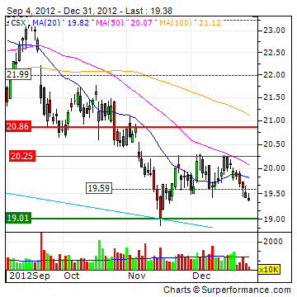
As youcansee in thischart, the stock hastaken a hitsince August. Buythedips, addtothecore, and catch a betterdividendyield. CSX is not goingawayandthecompanyhas a very strong balancesheet.
Yes, theyhad a down quarterrecently, but thecompanyshouldbounce back astheeconomydoes. Fornow, thedipisourbuysignal.

2.1.2013
Railroad Story: CSX Is Delivering On The Right Track With Improving Margins
CSX Corp (CSX), a Class I railroad in the United States,providesrail-basedtransportationservices, including traditional railserviceandthetransportof intermodal containersandtrailers. CSX operates 21,000 milesoftrackandhaulsshipmentsofcoalproducts (32% ofconsolidatedrevenue), chemicals (14%), intermodal traffic (12%) andothermerchandise. Since 2003, the Company had been improving ist net margin from 3.16% to the current 15.84%, ttm. The return on equityhad also beenimproveddramaticallyfrom 3.88% in 2003 tothecurrent 21.69%, ttm. Despitethe 16% declineofcoalvolume in thefirstthreequartersof 2012, CSX managedtoimproveitsoperatingmargincontinuously, ascomparedtothe 15.82% margin in 2011. Withitsstableoutlook, strong balancesheetandcontinuedoperationimprovement, CSX isexpectedtogenerateconsistent cash flowforitsinvestors.
Revenue, EarningsEstimate,andAnalysts'Calls
Forthecurrentquarter, analystsareexpecting $2.87B revenue, ascomparedtothe $2.95B forthe same quarter last year. Analystsare also expecting $11.75B revenue forthe 2012 fiscalyearand $12.07B forthe 2013 fiscalyear.
In thepast 90 days, the EPS estimatehadbeenlowered to $0.40 from $0.46 forthecurrentquarter. The fullyear EPS estimate was also loweredto $1.75 from $1.84. Analystsarecurrentlyprojecting an EPS of $1.89 for 2013, which was also loweredfrom $2.05 ascomparedto 90 daysago, asseenfromthetablebelow.
(click to enlarge)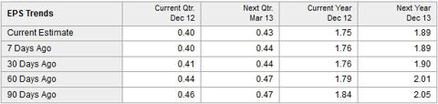
Increasing Net Income
As seenfromthesimplifiedincomestatementbelow, CSX continuedtoachieveincreasingoperatingincomesince 2007. In 2009, CSX still managedtoachieveincreasingoperatingincomedespite a 19.67% drop in revenue, comparingtoyear 2008.
(click to enlarge)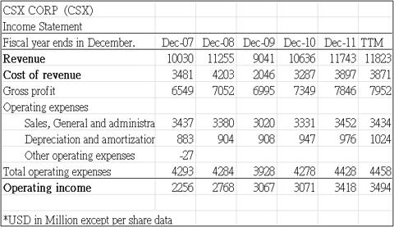
Since 2007, theoperatingmarginhad also beenimprovingfrom 17.99, 22.35 (2006), 22.49 (2007), 24.59 (2008), 25.27 (2009), 28.87 (2010), 29.11 (2011), tothecurrent 29.55, ttm.
As stated in CSX latest10-Qfiling, while CSX continuestostrengthenitscorebusiness, the Company isfocusing on threekeystrategicgrowth initiatives, including intermodal, exportcoaland Total Service Integration. CSX's Total Service Integration initiative was launched in 2006, which "supportsgrowthbyimprovingservice, optimizingtrainsize, andincreasingassetutilizationforunittrainshipmentsfromorigintodestination." Despitethedecreasedoperatingincome ($854 million) andslightlyincreasedoperatingratio (70.5%) due tolowervolume, primarily in coal, in Q3, 2012, CSX still managedtoimproveitsoperatingmargin to 70.1% in thefirst 9 monthsof 2012, ascomparedto 70.7% forthe same period in 2011. Withtheprojectedrevenueof $12.07B with $1.89 EPS, alongwiththeincreasingoperatingmargintrend, investing in CSX for 2013 makes sense. Thereis a high chancethat CSX will still achieveincomegrowth in 2013, evenwithouteconomicrecovery.
Valuation
CSX has a lower P/E of 11.0 ascomparedtotheindustryaverageof 14.6. The current P/E is also lowerthanCSX's 5 yearaverage of 14.2. CSX also has a lower P/B of 2.2, P/S of 1.7, and P/CF of 6.4, comparingtotheindustryaveragesof 2.6, 2.4, and 9.9, asseenfromthetablebelow. CSX is also tradingat 9.9 Forward Price/Earningsascomparedtotheaverageof 14.2 for the S&P 500. CSX iscurrentlyunder-valuedascompared to itscompetitorsandshoulddeserve a bettervaluation.
(click to enlarge)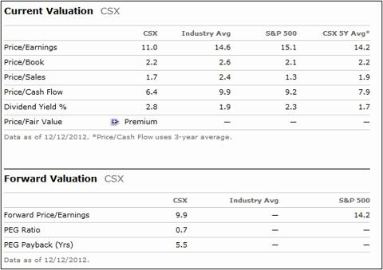
7.1.2013
CSX (CSX)
CSX Corporation (NYSE:CSX) is one of the nation's leading transportation companies. CSX's 30,000 employees operate a rail network comprised of more than 21,000 miles of track, 4,100 locomotives, 216,000 freight cars, and nearly 33,000 intermodal units.^{[1]} The company transports everything from chemicals to automotive parts. Its main divisions are Merchandise, coal , Intermodal (a combination of rail and truck transportation), and
Unions
Most of the 30,000 employees belong to labor unions, making CSX's relationship with the unions of utmost importance. The rail industry has been fortunate in the past, almost always reaching an agreement during negotiations before a strike becomes necessary. In the last thirty years, there were only six days of work stoppage due to labor negotiations.^{[4]}

Competition
Like other rail lines, CSX directly competes with the trucking and shipping industries. Trains are three times more fuel-efficient than their trucking competitors, but have less short-haul flexibility. As shipping imports from Asia continue to increase, analysts expect increased volume at many East Coast ports because West Coast ports already experience heavy congestion. Higher volumes flowing through the Suez and Panama canals also seem to support this assumption. In the rail industry, CSX's main competitor is Norfolk Southern (NSC), another East Coast rail line. CSX maintains a larger rail network, but Norfolk Southern consistently tops CSX in two of the three the main operating metrics: Train speed and average dwell time (the average time a car resides at the specified terminal location); CSX consistently has more cars online. Norfolk Southern also has a significantly better operating ratio (operating expenses / operating revenue) than CSX - 72.8% vs. 77.8%.
11.1.2013
Stop Paying Me A Dividend And Start Buying Back Shares
was not an efficient use of capital, and we would have been better off getting the cash in the form of a dividend.
So how does a shareholder know if their company is allocating cash efficiently? What metric should an investor look at to know if a company should be increasing its dividend or ramping up its share buyback program? The answer comes down to figuring out what constitutes an undervalued share price. In our mind, the formula is pretty simple. A company should only buy back its stock when its Price Earnings ratio (P/E) is less than its Return on Equity (ROE). ROE is how much income a company is earning from each dollar of equity invested in the firm. A P/E ratio is how much the market is willing to pay for a dollar of a company’s earnings. If the market is willing to pay more for a dollar of company earnings than the company can earn on its equity, then that dollar would be wasted on share buybacks and excess cash should be returned to shareholders. If the market underappreciates a company’s earnings power by assigning it a P/E ratio less than a company’s ROE, then buybacks are not a waste of the shareholder’s capital.
CSX Rail (CSX) P/E 11.7 ROE 19%

26.1.2013
CSX: Inside The Numbers
Determining a company's financial health is a very important step in making a decision on whether or not to invest or to stay invested. There are many different ways to compute a company's financial health. In the article below, I will be considering CSX Corporation's (CSX) profitability, debt and capital, and operating efficiency. Based on this, we get to see sales, returns, margins, liabilities, assets, returns and turnovers.
All numbers sourced from Morningstar.
Profitability
Profitability is a class of financial metrics used to assess a business's ability to generate earnings compared with expenses and other relevant costs incurred during a specific period of time. In this section, we will look at four tests of profitability. They are: Net Income, Operating Cash Flow, Return on Assets, and Quality of Earnings. From these four metrics, we will establish if the company is making money, and gauge the quality of the reported profits.
- Net Income 2010 = $1.563 billion.
- Net Income 2011 = $1.822 billion.
- Net Income 2012 TTM = $1.873 billion.
Over the past three years CSX's net profits have increased from $1.563 billion in 2010 to $1.873 billion in 2012 TTM. This signifies an increase of 19.83% in earnings over the past 3 years.
- Operating Cash Flow 2010 = $3.071 billion.
- Operating Cash Flow 2011 = $3.418 billion.
- Operating Cash Flow 2012 TTM = $3.494 billion.
Operating Cash Flow is the cash generated from the operations of a company, generally defined as revenue less all operating expenses, but calculated through a series of adjustments to net income.
Over the past three years, the company's operating cash flow has also increased. The CSX's operating cash has increased by 13.77%.
ROA - Return On Assets = Net Income/Total Assets
ROA is an indicator of how profitable a company is relative to its total assets. ROA gives an idea as to how efficient management is at using its assets to generate earnings. Calculated by dividing a company's net income by its total assets, ROA is displayed as a percentage. Sometimes this is referred to as "return on investment."
- Net income growth
  - Net Income 2010 = $1.563 billion.
  - Net Income 2011 = $1.822 billion.
  - Net Income 2012 TTM = $1.873 billion.
- Total Asset growth
  - Total Assets 2010 = $28.141 billion.
  - Total Assets 2011 = $29.473 billion.
  - Total Assets 2012 TTM = $29.930 billion.
- ROA - Return On Assets
  - Return On Assets 2010 = 5.55%.
  - Return On Assets 2011 = 6.18%.
  - Return On Assets 2012 TTM = 6.26%.
Over the past three years, CSX's ROA has increased from 5.55% in 2010 to 6.26% in 2012 TTM. This indicates that the company is making more money on its assets than it did in 2010.
Quality Of Earnings
Quality of Earnings is the amount of earnings attributable to higher sales or lower costs rather than artificial profits created by accounting anomalies such as inflation of inventory. To ensure there are no artificial profits being processed, the operating cash flow must exceed the net income.
2010
- Operating Cash Flow 2010 = $3.071 billion.
- Net Income 2010 = $1.563 billion.
2011
- Operating Cash Flow 2011 = $3.418 billion.
- Net Income 2011 = $1.822 billion.
2012 TTM
- Operating Cash Flow 2012 TTM = $3.494 billion.
- Net Income 2012 TTM = $1.873 billion.
Over the past three years, the operating cash flow has been higher than the net income. This indicates that the company is not artificially creating profits by accounting anomalies such as inflation of inventory.
Debt And Capital
The Debt and Capital section establishes if the company is sinking into debt or digging its way out. It will also determine if the company is growing organically or raising cash by selling off stock.
Total Liabilities To Total Assets, Or TL/A ratio
TL/A ratio is a metric used to measure a company's financial risk by determining how much of the company's assets have been financed by debt.
- Total Assets
  - Total Assets 2010 = $28.141 billion.
  - Total Assets 2011 = $29.473 billion.
  - Total Assets 2012 TTM = $29.930 billion.
  - Equals an increase of 6.36%.
- Total Liabilities
  - Total Liabilities 2010 = $19.455 billion.
  - Total Liabilities 2011 = $21.018 billion.
  - Total Liabilities 2012 TTM = $20.914 billion.
  - Equals a decrease of 7.50%.
Over the past three years, CSX has acquired more total liabilities than total assets. This indicates that the company has been financing its assets through debt. Over the past three years, the company's total assets increased by 6.36%, while the total liabilities increased by 7.50%.
Working Capital
Working Capital is a general and quick measure of liquidity of a firm. It represents the margin of safety or cushion available to the creditors. It is an index of the firm's financial stability. It is also an index of technical solvency and an index of the strength of working capital.
Current Ratio = Current Assets/Current liabilities
- Current Assets
  - Current Assets 2010 = $2.855 billion.
  - Current Assets 2011 = $2.935 billion.
  - Current Assets 2012 TTM = $2.393 billion.
- Current liabilities
  - Current liabilities 2010 = $2.537 billion.
  - Current liabilities 2011 = $2.687 billion.
  - Current liabilities 2012 TTM = $3.021 billion.
- Current Ratio 2010 = 1.13.
- Current Ratio 2011 = 1.09.
- Current Ratio 2012 TTM = 0.79.
Over the past three years, CSX's current ratio has decreased from 1.13 in 2010 to 0.79 in 2012 TTM. This indicates that the company has less of the ability to pay off its short-term obligations than it did three years ago. As the most recent number is below 1, this indicates that the company would not be able to pay off its obligations if they came due at this point.
Shares Outstanding
- 2010 Shares Outstanding = 1.09 billion.
- 2011 Shares Outstanding = 1.04 billion.
- 2012 Current Shares Outstanding = 1.03 billion (Google).
Over the past three years, the number of company shares has decreased. CSX Corporation's shares have decreased from 1.09 billion in 2010 to the current number of 1.03 billion. This is a decrease of 2.83%. This indicates that CSX is not issuing shares to raise money.
Operating Efficiency
Operating Efficiency is a market condition that exists when participants can execute transactions and receive services at a price that equates fairly to the actual costs required to provide them. An operationally efficient market allows investors to make transactions that move the market further toward the overall goal of prudent capital allocation without being chiseled down by excessive frictional costs, which would reduce the risk/reward profile of the transaction.
Gross Margin: Gross Income/Sales
The gross profit margin is a measurement of a company's manufacturing and distribution efficiency during the production process. The gross profit tells an investor the percentage of revenue/sales left after subtracting the cost of goods sold. A company that boasts a higher gross profit margin than its competitors and industry is more efficient. Investors tend to pay more for businesses that have higher efficiency ratings than their competitors, as these businesses should be able to make a decent profit as long as overhead costs are controlled (overhead refers to rent, utilities, etc.).
- Gross Margin 2010 = $7.349 billion / $10.636 billion = 69.10%.
- Gross Margin 2011 = $7.846 billion / $11.743 billion = 66.81%.
- Gross Margin 2012 TTM = $7.952 billion / $11.823 billion = 67.26%.
Over the past three years, the gross margin has decreased. The ratio has decreased from 69.10% in 2010 to 67.26%. As the margin has decreased, this indicates the company has been less efficient in its distribution.
Asset Turnover
The formula for the asset turnover ratio evaluates how well a company is utilizing its assets to produce revenue. The numerator of the asset turnover ratio formula shows revenue found on a company's income statement and the denominator shows total assets, which are found on a company's balance sheet. Total assets should be averaged over the period of time that is being evaluated.
- Revenue growth
  - Revenue 2010 = $10.636 billion.
  - Revenue 2011 = $11.743 billion.
  - Revenue 2012 TTM = $11.823 billion.
  - Equals an increase of 11.16%.
- Total Asset growth
  - Total Assets 2010 = $28.141 billion.
  - Total Assets 2011 = $29.473 billion.
  - Total Assets 2012 TTM = $29.930 billion.
  - Equals an increase of 6.36%.
As the revenue growth has exceeded the asset growth, this implies that the company is making money on its assets.
Based on the nine different criteria above, Overall CSX Corporation is showing strong results. The company is showing weakness in its current ratio and its assets to liabilities. The working capital indicates that the company does not have the liquidity it did a couple of years ago while the TL&A ratio is indicating that CSX is using debt to pay for its assets. Having stated that the other margins are showing strength, and as the above ratios indicate, overall, CSX is showing strong results regarding its financial health.
Analysts at Bloomberg Businessweek are estimating CSX's revenues to increase over the next couple of years. They are estimating CSX's revenue to be at 12.0 billion for FY 2013 and 12.6 billion for 2014. They are estimating an increase in profitability as they are predicting CSX to have an EPS at $1.84 for FY 2013 and $2.07 for FY 2014.
13.2.2013
CSX Corp. (CSX)
Quality Rating - A
Yield + DGR = 2.84 + 24.6 = 27.44
Payout ratio 31%
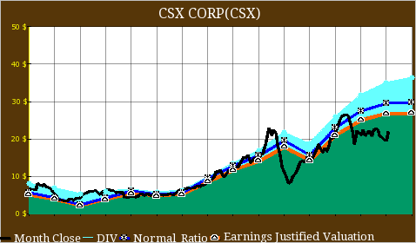
1
30.3.2013

CSX's Intermodal Business Is The Engine To Growth On Coal Weakness
Quick Take
- In a recent presentation, CSX reported that its overall volumes were down by 2% annually for the first eight weeks ending on February 22, 2013.
- CSX’s coal volumes and merchandising volumes were down by 14% and 2% annually for the period, respectively. However, intermodal volumes grew by 4% annually.
- We expect pricing to be a key factor for CSX’s revenue growth in 2013 as its volumes continue to be impacted by several headwinds.
- RPU within the merchandising and intermodal segment increased by 3% and 2% annually for the period, respectively. However, RPU within coal segment dropped by 3%.
CSX Corporation (CSX) is a leading railroad company in the eastern U.S. Its management recently presented at the JPMorgan aviation, transportation and defense conference on March 6, 2013. CSX reported that its overall volumes were down by 2% annually for the first eight weeks ending on February 22, 2013, as the company continues to face several headwinds. While CSX’s intermodal volumes grew by 4% annually and industrial shipments remained flat, all other sectors showed y-o-y decline in volumes. Its domestic and export coal volumes dropped by 17% and 6% annually for the period, respectively.
Facing several challenges, CSX aims to focus on areas such as safety, service, efficiency and inflation, plus pricing to drive its business in 2013. We believe pricing will be a key factor that will drive CSX’s revenues this year as its volumes continue to be impacted by weakness in the coal market. The revenue per unit (RPU) within merchandise and intermodal segments grew by 3% and 2% annually, during the first eight weeks of 2013, respectively. However, the RPU within coal business dropped by 3% for the period.
Performance Of CSX’s Different Segments During The First Eight Weeks Of 2013
Coal business continues to present headwinds
During the first eight weeks of 2013, CSX’s coal revenue was down by 16%, on account of a14% drop in CSX’s coal volumes coupled with a 3% decrease in coal RPU. Both domestic and export coal volumes declined through the period. While domestic coal volumes decreased by 17% annually due to higher coal inventories at utilities, export coal volumes dropped by 6% annually.
We think CSX will continue to face challenges in the domestic coal business in 2013, on account of higher coal inventories at utilities, which will limit their demand for new coal purchases.

Merchandise business shows unimpressive revenue growth
CSX’s merchandise business includes industrial, agricultural and construction sectors. During the first eight weeks of 2013, CSX’s merchandise revenues showed 1% annual growth, primarily on account of pricing gains as its merchandise volumes dropped by 2% annually during the period. The RPU within this segment rose by 3% y-o-y during the period.
- CSX’s industrial volumes were flat compared to the prior year. Its industrial volumes include chemicals, metals and auto shipments. While the chemical volumes expanded by 11%, metals and auto business posted a decline. The auto business was down by 2% annually, mainly on account of difficult y-o-y comparisons and loss of a contract. CSX estimates North American light vehicle production to grow by 3% in 2013, which will drive its automotive shipments in the year.
- CSX’s agricultural volumes dropped by 3% y-o-y in the period due to decline in grain volumes, which was partially offset by growth in phosphates and fertilizer shipments. We expect the agricultural market to stay challenging in the near term due to lower grain and ethanol shipments.
- CSX’s construction sector volumes were also down by 2% as higher building products volumes were offset by decreases in transportation equipment and paper volume.
While CSX’s merchandising volumes declined during the first eight weeks of 2013, however, its management expects the merchandise business to still grow in 2013.
Intermodal shipments drive growth at CSX
During the first eight weeks of 2013, CSX’s intermodal revenues were up by 6% annually due to a 4% rise in its intermodal volumes along with a 2% growth in RPU. While CSX’s domestic intermodal volumes grew by 7% on account of continued highway to rail conversions, international intermodal volumes were up by only 1%.

We expect intermodal business to be a growth driver for CSX on account of higher truck to rail conversions and its investments to improve service levels in this area.
15.4.2013
CSX: A Railroad Story That Keeps Moving And Improving
CSX Corp (CSX), a Class I railroad in the United States, provides rail-based transportation services, including traditional rail service and the transport of intermodal containers and trailers. As the profitability continues to improve, CSX's management has set an aggressive goal of achieving 65% of operating operation by 2015.
North America Railroad Landscape
In Western U.S., the railroads are dominated by Union Pacific (UNP) and Burlington Northern Santa Fe, which was acquired by Berkshire Hathaway's (BRK.A). On the East side, CSX and Norfolk Southern (NSC) take the lead. In Canada, Canadian National (CNI) and Canadian Pacific (CP) are in charge.
Analysts' Calls and Estimates
On April 12, 2013, Analysts at FBR are bullish on U.S. rail stocks. CSX and Norfolk Southern were upgraded to outperform with price targets of $30 and $90, respectively.
Analyst John R. Mims, who favors U.S. Class 1 rails versus both the Canadian rails and Kansas City Southern (KSU), said,
"Though all of the Class 1 rail stocks have had a big run in recent months, they have come in a bit ahead of earnings, yielding an attractive buying opportunity. Moreover, the backdrop in 2013 is increasingly favorable for the rails, as improving fundamentals are facing very easy YOY comps, and the stage is set for several years of robust earnings growth for the space."
Analysts currently have a mean target price of $25.91, suggesting 5.71% upside potential based on the closing price of $24.51 on April 12, 2013. Analysts, on average, are estimating an EPS of $0.40 with revenue of $2.91B for the current quarter ending in March, 2013. For 2013, analysts are projecting an EPS of $1.78 with revenue of $11.92B, which is 1.40% higher than 2012. CSX is expected to release its Q1, 2013 earnings on April 16, 2013. In the last 4 quarters, CSX had 4 positive earnings surprises.
Fundamentally, CSX's key stats will be compared to other competitors in the industry of railroads, including Norfolk Southern, Union Pacific, and Canadian National.
 | CSX | Norfolk Southern | Union Pacific | Canadian National | Industry Average
Market Cap | $25.02B | $24.12B | $66.30B | $41.77B | N/A
Revenue Growth (3 Year Average) | 9.2 | 11.5 | 14.0 | 2.1 | 1.8
Operating Margin, %, ttm | 29.4% | 28.3% | 32.2% | 36.9% | 27.7%
ROE | 21.3 | 17.8 | 20.5 | 23.2 | 17.2
Debt/Equity | 1.0 | 0.9 | 0.4 | 0.5 | 0.6
P/E | 13.6 | 14.1 | 17.1 | 16.4 | 18.0
5 Year Avg. P/E | 13.2 | 14.0 | 15.1 | 14.1 | N/A
P/B | 2.8 | 2.4 | 3.3 | 3.7 | 3.1
Source: Morningstar
CSX's revenue growth is much higher than the industry average and Canadian National but slightly lower than Norfolk Southern and National Pacific. CSX also has an operating margin higher than the industry average and Norfolk Southern (on the east end). From the valuation perspective, CSX's current P/E is lower than the industry average but higher than its 5 year average P/E.
Below, CSX's operating margin and sales estimate will be compared to these 3 companies, as seen from the charts below.
(click to enlarge)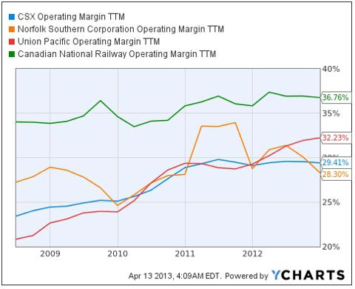
Source: YCharts.com
Comparing to NSC, CSX had a steady increase of operating margin since 2008 and reached 29.41% operating margin by the end of 2012. On the other hand, CNI's operating margin had been fluctuating between 34-36% for the same period. UNP also had an impressive operating margin improvement and reached 32.23% operating margin by the end of 2012.
(click to enlarge)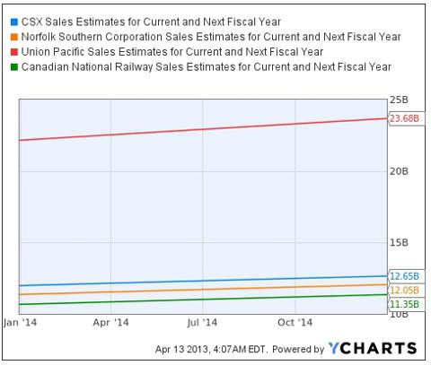
Source: YCharts.com
Sales Estimates are expected to increase for all 4 companies, whereas CSX's revenue is expected to reach $12.65B by the end of 2014.
17.04.2013
Transportkonzern CSX steigert die Dividende und kauft eigene Aktien

Der Transportkonzern CSX Corporation (ISIN: US1264081035, NYSE: CSX) wird die Quartalsdividende um 7 Prozent auf 0,15 US-Dollar anheben. Damit werden hochgerechnet auf das Jahr zukünftig 0,60 US-Dollar ausgeschüttet. Dies entspricht beim derzeitigen Aktienkurs von 24,14 US-Dollar einer aktuellen Dividendenrendite von 2,48 Prozent.
Aktionäre erhalten die nächste Auszahlung am 14. Juni 2013 (Record date: 31. Mai 2013). Seit 2005 wurde die Dividende insgesamt 11mal erhöht. CSX wird in den nächsten 24 Monaten eigene Aktien im Volumen von 1 Mrd. US-Dollar zurückkaufen. CSX führte im Juni des Jahres 2100 einen Aktien-Splitt im Verhältnis 3:1 durch.
Der Konzern aus Jacksonville in Florida ist im Transportwesen tätig. Unter anderem zählt die Eisenbahngesellschaft CSX Transportation zum Unternehmen. CSX ist damit die drittgrößte Eisenbahngesellschaft in den USA. Das Schienennetz der CSX Corporation entspricht einer Strecke von rund 21.000 Meilen.

