15.12.2012
Einfluß von Wechselkursen!
Zum 1.1. kostet 1 € = 1,5$. ( Euro ist stark geworden, Dollar ist schwach geworden)
Eine Aktie kostet 3 $ = 2 €
Zum 31.12. kostet 1€ = 1,2 $ ( Euro ist schwach geworden, Dollar ist stark geworden)
Eine Aktie kostet 3,6$ = 20 % Kursgewinn
3,6 $ sind aber 3 €.
In Euro gerechnet habe ich 50 % Kursgewinn ( 2 Euro invest, 3 Euro zurück)
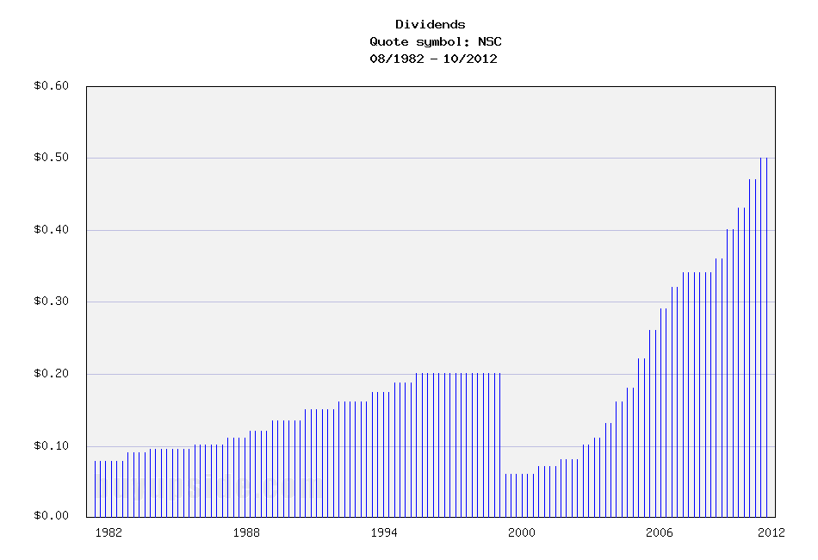
Norfolk Southern (NSC),
The Class I operators in the United States appear to be reasonably valued for long-term returns. The balance sheets are in solid condition, they all have competitive advantages against new competitors entering the market, and some of them pay decent dividend yields.

The Rail Renaissance
Ever since the 1980s when deregulation allowed the rail companies to operate more profitability, railroad stocks in general have enjoyed market-beating returns. Improved automation technologies, increasing congestion of highways (which haven't kept up with increases in car and truck traffic since the construction was initiated under President Eisenhower), and changes in energy costs (railroads are far more efficient with fuel than trucks are), have allowed railroads to improve their operating margins over time.
Investors have different approaches to stocks that have performed well. Some investors believe that buying stocks in an uptrend is a smart buying approach, while other investors believe the exact opposite, and instead look to enter positions after big setbacks.
A more fundamental approach is to ignore previous stock movements, and simply focus on the question of whether the current price is fundamentally undervalued, fairly valued, or overvalued compared to the intrinsic value calculated by estimates of forward-looking performance.
Despite the fact that many of these railroad stocks have already outperformed, some of the most-followed value investors that buy with very long-term horizons are the biggest owners in these companies. Bill Gates, and more specifically through his value-investing chief investment officer Michael Larson, is the largest shareholder of Canadian National Railway (CNI). Warren Buffett took it a step further and acquired the entirety of the Burlington Northern Sante Fe railroad in 2010, and this was his largest acquisition ever.
Based on valuation methods such as the Dividend Discount Model, many of these stocks appear poised to offer returns in the low double-digit range.

Returns Come Mostly From Shareholder Yield, Not Growth
One thing all of the railroad companies have in common is that they are using their free cash flow to buy back their own shares in large numbers and pay moderate-yielding dividends.
The shareholder yield of a stock is the sum of dividends and share buybacks divided by market capitalization.
In other words, if a company pays a 3% yield and buys back 4% of its shares each year (net of shares issued), then the shareholder yield is 7%. That's essentially the expected long-term rate of return the investor gets when 0% core growth is expected. When there is growth, it is on top of the shareholder yield, and the shareholder yield is the internal rate of return the company can keep giving shareholders as long as it has stable free cash flows. If the railroad can boost actual volume by 1-2% per year over the long-term (they've been going a lot faster than that lately, but it's part of a rebound and won't continue indefinitely), and then maintain pricing power of 2-3% increase per year (or in line with whatever the inflation rate is over the period), then another 3-5% rate of return is added onto the shareholder yield.
Investing for the long-term in these railroad stocks, in other words, is basically a bet or estimate that they won't decline in business. As long as they perform flatly, or have 1-2% growth and maintain pricing power, returns can be in the high single digits or low double digits over the next decade. There won't be tremendous growth as there was over the last 25 years, but the industry appears to be a good one to put some capital. The companies can just keep chugging along, reducing the share count and raising their dividends, so that long-term investors can own larger and larger portions of the company and increase the yield on cost.

Risks that Could Threaten the Industry
Authors of articles such as this, this, this, and this (in chronological order), have voiced concerns over the risk that high-speed passenger lines, desired by the federal government, may harm freight railroad companies, or at least show the involvement government has to have with these freight lines in order to proceed.
During the unprofitable period of regulation of railroad stocks, the companies had to serve places that were not profitable to serve. The government proponents of high speed rail currently have to work with the freight companies to use some of their infrastructure, which can impact the efficiency of freight shipping.
It's not a sure-fire problem. With proper planning, passenger trains and freight rail can coexist profitably. Nonetheless, it remains a risk for the industry.
If you like the fundamentals of the industry but want to increase your margin of safety and enter positions with a lower cost basis, selling put options can reduce the cost basis by 10% or so.

How to Play It
The Class I railroads in the United States are Norfolk Southern (NSC), CSX Corporation (CSX), BNSF (owned by BRK.B BRK.A), Union Pacific (UNP), and Canadian National Railway (CNI).
(click to enlarge)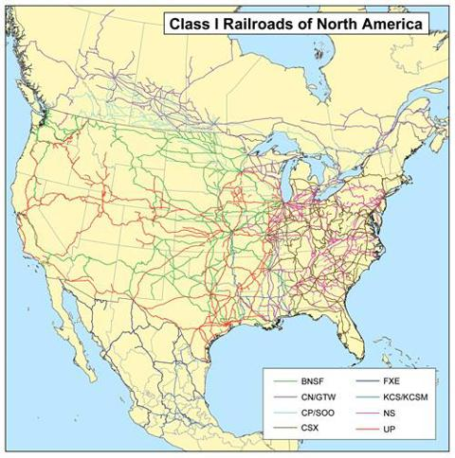
Image source
Focusing on the U.S. rail lines, the railroad stocks are divided into two or three groups.
Eastern Group
The eastern group consists of CSX Corporation and Norfolk Southern. They share very similar geographic positions across the eastern half of the United States. What you'll see if you look at the stock price history is that they both took large recent stock price hits (especially NSC), because their coal volumes dropped substantially.There appears to be a long-term trend of natural gas replacing coal for electricity generation, and since three out of the top five states for coal production are in the eastern third of the country, these rail lines have a disproportionate share.
These two companies are also a bit more leveraged than their western counterparts. They took on a bit more debt to buy back shares more aggressively. Still, since they don't have goodwill from acquisitions and their interest coverage ratios are comfortable, their balance sheets are fair.
The coal headwind and the slightly more leveraged positions have resulted in earnings multiples of only around 11 for both of these companies. These two can be considered the "value plays" out of the five companies.
A decent play to add or increase exposure to railroad stocks is to diversify across an eastern and a western railroad, or CNI and one of the eastern or western railroads.
Here's an overview of the current dividends of each stock:
Company | Yield | Payout Ratio
BNSF (Berkshire Hathaway) | 0% | 0%
Canadian National Railway | 1.65% | 25%
Union Pacific Corporation | 2.23% | 34%
CSX Corporation | 2.81% | 31%
Norfolk Southern | 3.25% | 36%

15.12.2012
Norfolk Southern Corporation (NSC) Dividend Stock Analysis
Norfolk Southern Corporation (NSC), through its subsidiaries, engages in the rail transportation of raw materials, intermediate products, and finished goods primarily in the United States. This dividend achiever has paid uninterrupted dividends on its common stock since 1901 and increased payments to common shareholders every for 11consecutive years.

The company’s last dividend increase was in January 2012 when the Board of Directors approved a 9.30% increase to 47 cents/share. This marked the second dividend increase over the past year. Norfolk Southern‘s largest competitors include Union Pacific (UNP), CSX (CSX) and Canadian National Railway (CNI).

Over the past decade this dividend growth stock has delivered an annualized total return of 17% to its shareholders.
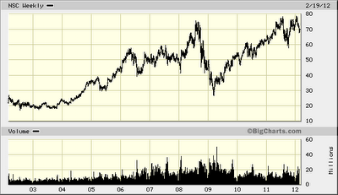
The company has managed to deliver an 18.50% annual increase in EPS since 2002. Analysts expect Norfolk Southern to earn $5.96 per share in 2012 and $6.71 per share in 2013. In comparison Norfolk Southern earned $5.45 /share in 2011. The company has managed to consistently repurchase 3% of its outstanding shares on average in each year over the past five years.
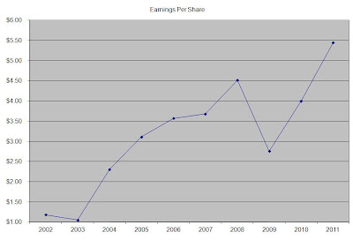
A bet on railroads is a bet on the long-term growth of US economy. As the country expands, and as the population grows over the next few decades, the amount of goods that would need to be transported will surely increase. Currently, railroads have an important advantage over trucks for example, since they are three times more fuel efficient and could also carry certain hazardous materials that trucks cannot transport. This being said, railways in general will experience cyclicality in earnings during recessions. There are only four major railroads in the US, including Burlington Northern Santa Fe, Union Pacific, Norfolk Southern and CSX Corp. Analysts expect railroad transportation volumes to increase by 1.50% per year over the next decade.

For Norfolk Southern in particular, half of revenues come from transporting goods which are sensitive to the economic cycle, such as automobiles and chemicals. Almost one third of revenues are generated by transporting coal to utilities, which is one of the most profitable activity for the company. The remainder of revenues are generated by the company’s intermodal business, where it directly competes with trucker companies for volume. The company has invested heavily to increase its competitiveness along key freight lanes by adding infrastructure to support intermodal transportation of goods.

The company’s return on equity has increased from 7.50% in 2002 to 18.60% in 2011. Rather than focus on absolute values for this indicator, I generally want to see at least a stable return on equity over time.
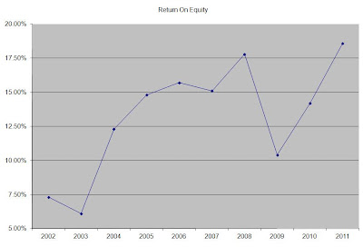
The annual dividend payment has increased by 21.30% per year over the past decade, which is higher than to the growth in EPS.
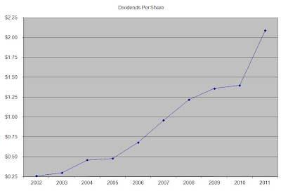
A 21% growth in distributions translates into the dividend payment doubling every three and a half years. If we look at historical data, going as far back as 2001 we see that Norfolk Southern has managed to double its dividend almost every three and a half years on average.

The dividend payout ratio has almost doubled from 22% in 2002 to 39% in 2011. A lower payout is always a plus, since it leaves room for consistent dividend growth minimizing the impact of short-term fluctuations in earnings.
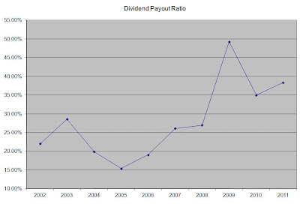

Currently Norfolk Southern is attractively valued at 12.60 times earnings, has a sustainable dividend payout and yields 2.80%.
21.12.2012
2 Cheap Railroad Stocks To Buy For 2013
Overview
As part of the volatile transportation sector, railroad stocks can sometimes be overlooked as potentially compelling investments. Rail stocks are sensitive to changes in fuel prices, as well as to fluctuations in freight prices. The US stocks recommended in this article are cheaper than their Canadian counterparts such as Canadian Pacific (CP) and Canadian National Railway (CNI), which trade at 17.5x and 14.7x 2013 earnings estimates, respectively. The companies below have market caps of at least $19 Billion, have dividend yields of at least 2.9% and trade for less than 11x 2013 earnings estimates.
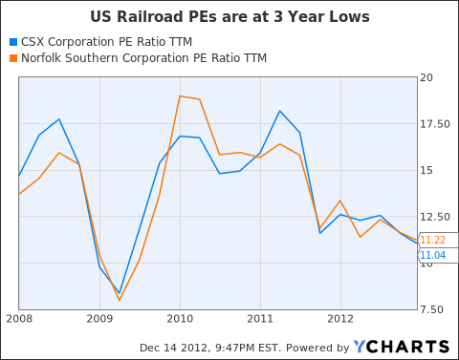
CSX (CSX)
Norfolk Southern (NSC)
Market Cap: $19 Billion
Dividend Yield: 3.29%
Estimated 2013 PE Multiple: 10.8x
Norfolk Southern, another premier railroad company, is down almost 17% over the past year. The company operates approximately 20,000 miles of rail track in 22 US states as well as in Washington DC. The company has increased its dividend per share at a CAGR of 22% from 2002 to 2012. Norfolk Southern is optimistic about the increased business that it should receive as a result of the "Shale Boom" in the US. The company has initiated a few new capital plans that should help the company increase volume and profitability. The company has a healthy 3.29% dividend yield and trades at a reasonable earnings multiple of 10.8x 2013 estimates.
23.12.2012
Norfolk Southern: Interesting Value
Norfolk Southern (NYSE: NSC) operates a large railroad system that serves most of the eastern United States.
-Seven Year Revenue Growth Rate: 3.9%
-Seven Year EPS Growth Rate: 8.7%
-Seven Year Dividend Growth Rate: 21.4%
-Current Dividend Yield: 3.31%
-Balance Sheet Strength: Fair
The intrinsic fair value of this company has a large window due to the uncertain nature of their declining coal segment. I estimate that the current price of $60 falls within this reasonable window, and that writing options to potentially enter at a cost basis in the low $50′s through 2013 presents a larger margin of safety.
Overview
Norfolk Southern Corporation is a large railroad company with over 20,000 miles of track in 22 states, with connections to every major container port in the eastern United States. The company is based in Norfolk, Virginia, and came into its current form in the early 1980′s as a result of a merger.
General Merchandise Traffic
This is the largest and most diverse group of transported materials for the company. General merchandise accounted for 50% of 2011 revenue for the company, and can be broken down into five major groups:
-Automotive
-Chemicals
-Metal and Construction
-Agriculture, Consumer Products, and Government
-Paper, Clay, and Forestry Products
Coal Traffic
The transportation of coal accounted for 31% of Norfolk Southern's 2011 revenue. The coal is used for electricity generation, export, metallurgical use, and industrial use. Of the nearly 178 million tons of coal shipped in 2011 by the company, 122 million of those tons were used for utility/electrical generation, 28 million tons were used for export, 20 million tons were used for metallurgy, and 8 million tons were used for industrial use.
Intermodal Traffic
Norfolk Southern transports trailers and containers, and this accounted for 19% of 2011 revenue.
Ratios
Price to Earnings: 11
Price to Free Cash Flow: 28
Price to Book: 2
Return on Equity: 18%
Revenue
(click to enlarge)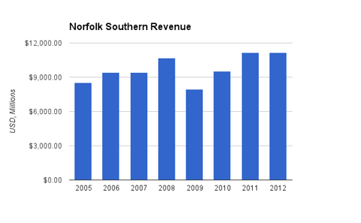
For these two charts, the "2012″ figure is the current trailing twelve month figure. Revenue grew by an annualized rate of 3.9% over this time period, with a major reduction occurring during the economic recession.
Earnings and Dividends
(click to enlarge)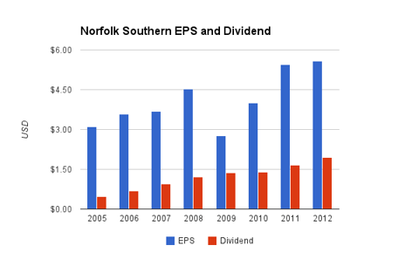
Earnings per share increased by an average of 8.7% per year over this period despite the recession. This EPS growth was primarily driven by share repurchases.
The average annual dividend growth rate over this period was 21.4%, which is a combination of the EPS growth rate and a steadily increasing payout ratio. Over the long term, dividend growth must slow down to match EPS growth. However, with a payout ratio of only 35% (despite the sizable 3.31% dividend yield), the company has quite a cushion of dividend growth and dividend safety. This is somewhat lowered by their recent reduction in free cash flow, but that is discussed later and overall I believe the dividend is safe and in a position to continue growing.
Approximate historical dividend yield at beginning of each year:
Year | Yield
Current | 3.31%
2012 | 2.3%
2011 | 2.2%
2010 | 2.5%
2009 | 2.6%
2008 | 2.2%
2007 | 1.5%
2006 | 1.2%
2005 | 1.1%
How Does Norfolk Southern Spend Its Cash?
For the fiscal years 2009, 2010, and 2011, Norfolk Southern brought in nearly $2.8 billion in free cash flow. Over the same period, the company spent approximately $2.6 billion in net stock buybacks and nearly $1.6 billion in dividends.
Back in 2006, the company hit a peak share count of around 415 million but has brought that number down to 325 million due to regular and aggressive share repurchases. This is why despite company-wide net income only increasing at a 3.5% annualized rate between 2006 and the present day, earnings per share have increased at a 7.7% annualized rate over that same period.
Balance Sheet
Nortfolk Southern has a debt/equity ratio of approximately 85%, a debt/income ratio of a bit over 4.5x, and an interest coverage ratio of over 6.5x.
The company is using a moderate amount of leverage, but the balance sheet is in fairly good shape and debt interest is very well covered by income.
Total debt has increased from under $6 billion in 2007 to over $8 billion in 2012. The company's debt levels do fluctuate over time, and the low interest rate environment has made leverage more appealing. This increase in debt essentially went to buying back shares, so they take on money at a lower rate of return to invest in an asset (their own stock) with a potentially higher rate of return. This makes sense to do as long as the balance sheet remains robust.
The company cannot do this perpetually, so the past few years of aggressive share buybacks should be assumed to be reduced a bit in the future unless core company income growth accelerates. This is particularly unlikely given their problems with coal, to be mentioned later.
Investment Thesis
Back in September of this year, Norfolk Southern had a stock price of approximately $75. Due to the most recent quarterly report, the stock dropped to around $56 and has since rebounded to $60. I believe a portion of this stock drop was rational; alarming decreases in coal transportation were the sole problem, and FCF levels took a hair cut.
However, capital expenditure during 2011 and 2012 has been significantly higher than historical levels. Free cash flow dropped 35% for the trailing twelve month period compared to the 2011 calendar year (which itself was moderately lower than the 2010 calendar year), but operating cash flow dropped less than 9% for the trailing twelve month period compared to the 2011 calendar year. The difference was due to the increases in capex.
Therefore I believe a 25% stock price drop from $75 to $56 was a moderate over-correction. The company has a fairly diverse revenue base, and while coal transportation presents a headwind for the company, it may also present a value opportunity for this railroad dividend grower.
Risks
Railroads commonly face the general risk of economic downturns. Reduction in economic activity means reduction in transportation. It's nonlinear due to the high fixed costs, so mild or moderate decreases in rail traffic reduce free cash flow and earnings to a significant extent, and then mild or moderate increases in that traffic for the rebound boost free cash flow and earnings to a significant extent. The recession cut Norfolk Southern's free cash flow in half for 2009, and reduced return on equity from over 17% down to around 10%. These rebounded, but are now threatened by reductions in coal volume.
Nearly a third of the company's revenue comes from transporting coal, and the largest use of that coal is for generating electricity. In 2011, 31% of revenue came from coal, but this dipped to under 27% recently. The latest quarter showed a significant decline in coal shipping, and their FCF bounced low enough to barely cover the dividend (although with cash and debt the company can smooth those problems out and easily protect the dividend over the moderate term). Management cited highly competitive natural gas prices as the primary driver of the reduction in coal demand.
23.12.2012
Norfolk Southern's Future Isn't As Tied To Coal As You Think
Railroads have always played a great role in supporting the growth of the US. One of the greatest railroad companies operating in the country is Norfolk Southern Corporation (NSC), which along with the other Class I US railroads, account for 93% of total railroad freight revenue. Class I railroads are those with revenue greater than $398.7 and there are 7 of them operating in the United States. Apart from Norfolk Southern Corp. there are: BNSF Railway (owned by Berkshire Hathaway - BRK.A, BRK.B), CSX Transportation (CSX), Grand Trunk Corporation (owned by CNI), Kansas City Southern (KSU), Soo Line (owned by CP) and Union Pacific Corporation (UNP).
Norfolk's stock price had a 28% decline to $56.05 from its January high of $78.5. This happened due to an accelerating trend among electric utilities to change from using coal to natural gas and take advantage of the latter's lower price. Coal usage and the railroad freight industry have traditionally been closely tied together, since 70% of the coal used in power plants is transported by rail. In addition, coal accounts for approximately 43% of the commodities Class I rail moves, based on weight, and generates around 25% of total freight revenue.
As a result of its stock price falling, Norfolk Southern has now an attractive P/E ratio of 10 and a juicy 3.4% dividend yield. In this report we will stress test NSC under various possible scenarios and find out under which conditions it would make for a good investment opportunity.
NSC Stock Info November 29, 2012
Stock Price | $60.48
Dividends per share (Paid in 2012) | $1.94
Dividend yield | 3.20%
Price/earningsratio | 10.74
Earnings per share, 2012 (estimate) | $5.64
Shares outstanding, September 30, 2012 | 316,043,185
Norfolk Southern has a moat around its business as all the big railroad companies do. Its assets are practically impossible to replicate. The cost and hurdle to obtain rights-of-way and build a new track makes it practically impossible for a new competitor to enter this business. As for what its business is, here it is directly from its corporate website:
Below is Norfolk Southern's railroad network, along with its revenue breakdown to various sources:
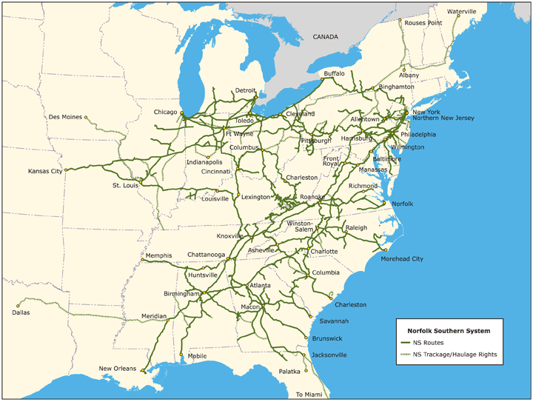
Principal Operating Revenue Sources September 30, 2012
Coal, coke, and iron ore | $ 2,222
Intermodal | $ 1,657
Agriculture, fertilizer, and consumer products | $ 1,084
Chemicals | $ 1,111
Metalsandconstruction | $ 1,025
Automotive | $ 668
Paper, clay and forest products | $ 589
Total Revenues | $ 8,356
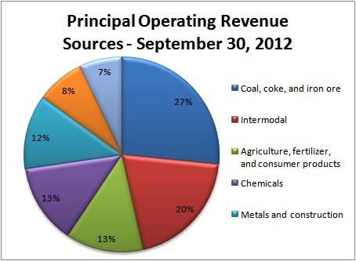
Coal's share in Norfolk Southern's revenues has declined from a 31% high in 2011 to just below 27% for 2012. This is a big change and if natural gas continues to be cheaper than coal, Norfolk's related revenue is bound to shrink.
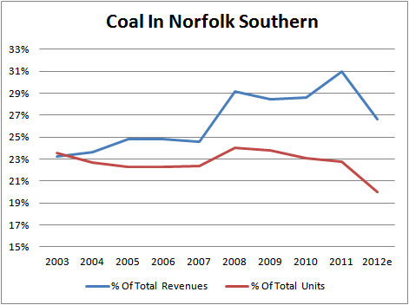
Moreover, Norfolk transports primarily the most vulnerable coal variety, Appalachian coal. Unfortunately for Norfolk, Appalachian coal is the most expensive coal to use and thus it's the first one power plants are abandoning mostly in favor to natural gas. However this process isn't so easy and requires some time, since power companies have to adjust their equipment and facilities according to the characteristics of the new fuel they're going to use.
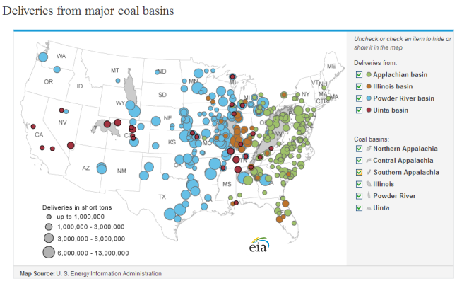
But, things are not so bad for Norfolk as they seem. After 2009 revenue increased faster than the quantity of goods transported, which means that Norfolk has some pricing power over its customers. Although this won't prevent the eventual coal revenue decline, it will help to slow it down, giving Norfolk's management the necessary time to grow its business from other revenue sources. So far, traffic growth for commodities in 2012, excluding coal, has compensated for coal's decline and helped to keep revenue and profits steady.
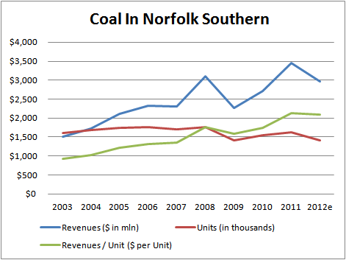)
)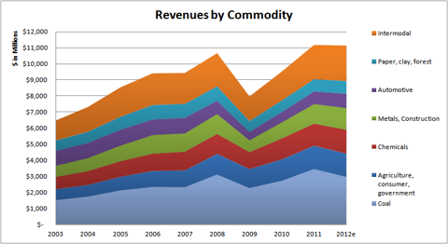(
Moving on, let's talk about valuation and find out how much Norfolk Southern is really worth. To do that we will calculate Norfolk's next year's earnings under 5 possible scenarios:
- Coal revenue goes to zero. Everything else stays the same. In this case we will try to calculate a worst case valuation for the stock.
- Coal revenue shrinks further, to 20% of 2012 revenues. Everything else shrinks 10% due to recession.
- Coal revenue shrinks further, to 20% of 2012 revenues. Everythingelsehas 0% growth.
- Coal revenue slips further but the other commodities grow and cover it. Revenue staysstableat 2012 levels.
- Coal stabilizes to 22% of 2012 revenue and everything else goes up 5%
(click to enlarge)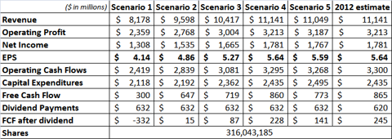(Data fromNorfolk Southern'sSEC filings)
- To calculate operating profit and net income I presume that profit margins will neither improve nor deteriorate significantly.
- Earnings per share - EPS, are calculated using the number of shares outstanding as of September 30, 2012. No potential buybackactivityisfactored in.
- To calculate how much capital expenditures will drop I applied the revenue decline rate cut in half. Although CAPEX is quite volatile, it seems to loosely correlate with revenue. It is moving in the same direction with it when there's a significant change, albeit it does it with half the rate of change. For example if revenue declines 10% CAPEX will decline approximately the half of that, which is 5%.
- For dividend payments I presume a $2 dividend, as it was after the last raise.
- To calculate cash flows I assume that in 2013, operating cash flow will be about 1.85 to 1.95 times earnings, as it was for the last 3 years.
Keep in mind that these "scenarios" are not supposed to be accurate predictions of what's going to happen, but a crude tool to help us evaluate Norfolk's intrinsic value.
What this table tells us is that even at the impossible case that Norfolk stops moving coal for one reason or another, an approximate value range for the stock would be between $40 (10 P/E) and $50 (12 P/E). This puts a bottom for the value of the stock 17% to 30% below the current price level.
However, this outcome is highly improbable because, as I mentioned above, changing the fuel a power plant uses isn't done in a day. In addition there are other things to consider. Moreover it doesn't make sense for a power plant to completely cut its coal consumption, it will just reduce it instead to quite low levels. That is because having a back-up alternative source is the sensible thing to do. Moreover coal will eventually become cheaper or at least equally priced to natural gas, which by the way may have hit its bottom at a historically low price and now is moving up again.
(clicktoenlarge)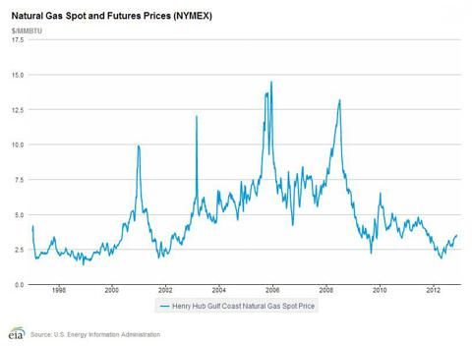
The most probable scenario in my opinion is the fourth one that anticipates that the decline in coal revenues will be matched by an equal revenue increase in the other goods Norfolk transports. Using the same P/E range as with the previous calculation, Norfolk's stock would have in this case a fair value range between $55 to $70. Add to that the $1.9 per stock excess cash it has and fair value goes up a bit to $57 to $72.
But this isn't the whole story. Norfolk Southern Corporation is also giving back to shareholders a lot of value, mainly through its shares buyback program and its (currently) 3% dividend.Norfolk has done a good job buying back its own stock, reducing its shares outstanding from 415 million at the end of 2006 to 316 million to the end of Q3, 2012. That's an amazing 24% reduction.
Norfolk is also paying a nice dividend which going forward in $0.50 per quarter. Except in our extreme no-coal scenario, this dividend is fully covered for the next year as you can see from the "FCF after dividend" item in the above table. Unfortunately FCF is just enough for the dividend and Norfolk may have to increase its long-term debt to cover for other needs that may occur. However, this won't be a problem since its total debt is less than its shareholder equity and EBIT for 2013 - even in our worst scenario - will be more than 4 times its interest payments.
Conclusion
- Coal's importance for Norfolk has declined a lot in 2012 and given the same trends continue into 2013, Norfolk will become less and less dependent on coal either for revenue or growth.
- The stock has a rock-solid value bottom at $40 applicable in the case than Norfolk drops the coal transporting segment altogether.
- The rest of the goods Norfolk transfers are doing great and along with price increases in coal freights, they will probably offset any coal-driven revenue decline.
- Norfolk has a great and consistent share buy back program plus a safe and juicy 3% dividend.
- Norfolk Southern's fair value range is $57 to $72. At these levels it is a nice 20% opportunity. Especially if it creates an entry point by going down 6% to $57 and below.
24.12.2012
Norfolk Southern Corporation (NSC) is a rail transportation company with a market cap of $19.4 billion. The company pays a dividend yielding 3.3% on a low payout ratio of 36%.Its competitors Union Pacific (UNP) and CSX Corp. (CSX) are paying lower dividend yields of 2.2% and 2.8%, respectively. Over the past five years, the company's EPS and dividends grew at average annual rates of 8.8% and 15.1%, respectively. Analysts forecast that Norfolk Southern's EPS will expand at a faster rate of 12.7% per year for the next half decade, which would suggest future dividend hikes. The past financial results were hurt by lower volumes of Appalachian coal shipments, which accounted for 31% of the company's revenue in 2011. However, the rising natural gas prices are improving the competitive position of coal, and coal prices and shipments may improve sometime in 2014. In the meantime, intermodal traffic, accounting for about 20% of sales, is picking up. Moreover, any improvement in macroeconomic conditions will support higher general merchandize traffic, which is dependent on the automotive, chemicals, farm, and paper industries. The company is also improving service capacity and network efficiency as well as buttressing its EPS growth through stock buybacks. Norfolk Southern has an ROE of 18%. Its stock is trading on a forward P/E of 11.3, a discount to its respective industry (with the ratio of 13.2). Legg Mason Capital Management and D. E. Shaw (check out its top positions) have positions in the stock.

27. Dezember 2012, 14:46 Uhr

Kanalerweiterung

Panama-Flutwelle trifft deutsche Häfen
Von Markus Gärtner
In einem Jahr wird die Erweiterung des Panama-Kanals für Megafrachter abgeschlossen. Der Gewinner steht bereits fest: China. Deutsche Häfen wie Hamburg drohen im Kampf um die Superschiffe leer auszugehen.
Vancouver - Mit der Jahreswende rückt der nächste Meilenstein in der Globalisierung näher. Die Erweiterung des 77 Kilometer langen Panama-Kanals wird in einem Jahr abgeschlossen sein. Der künstliche Wasserweg revolutionierte 1914 mit seiner Fertigstellung den globalen Güterhandel. Er verkürzte den 22.000 Kilometer langen Seeweg von New York nach San Francisco auf 9600 Kilometer, weil die lange Umrundung des südamerikanischen Kontinents seitdem entfällt.
Derzeit wird letzte Hand an die dritte Spur des Kanals angelegt und zwei supergroße Schleusen zu Ende gebaut. Dann können sich die Megaschiffe der Post-Panamax-Klasse durch den Kanal schieben. Sie sind doppelt so groß wie bisher und führen mit 15.000 Containern drei Mal so viel Fracht.
Die Folgen für den Welthandel sind weitreichend und machen Hafendirektoren und Frachtmanager bis nach Hamburg ziemlich nervös. Denn die Post-Panamax-Schiffe machen trotz eines Anteils von erst 16 Prozent der Flotte bereits 45 Prozent der Frachtkapazität auf den Weltmeeren aus. Bis 2030 soll ihr Kapazitätsanteil auf 62 Prozent steigen. Der erweiterte Panama-Kanal wird ein großer Treiber dieser Entwicklung sein.
Von den USA bis nach Europa sind jedoch nur wenige Häfen im Zeitplan mit der nötigen Vertiefung von Hafenbecken und Brückenvergrößerungen, um die rasch wachsende Zahl der Ozeanriesen mit ihrer vollen Last aufzunehmen. Während die Nachzügler in diesem Wettlauf gegen die Uhr kämpfen, reiben sich die großen Gewinner bereits die Hände: Asiens, vor allem Chinas Zugang zu den großen Absatzzentren im Osten der USA wird billiger, schneller und leichter.
Kanalerweiterung hilft US-Industrie
Viel von der Fracht aus Fernost - Spielzeuge, Maschinen, PCs und Elektronik - wird bislang an der Westküste der USA in Häfen wie Los Angeles und Long Beach gelöscht. Dann werden die Container auf LKW gehievt oder auf Eisenbahnen verladen und quer durch die USA zu den Kunden gebracht.
Mit den Ozeanriesen, die künftig den erweiterten Panama-Kanal durchqueren können, ist es weitaus billiger, die Güter gleich in Häfen an der Ostküste zwischen Florida und New York zu bringen. Dort freut man sich, denn das zusätzliche Frachtvolumen mit Asien kann zumindest einen Teil der verlorenen Volumina im Handel mit dem rezessionsgeplagten Europa ausgleichen.
Mehr noch: Der leichtere Zugang für billig verschiffte Massenware und Maschinen wird die Rückverlagerung von Industrie nach Amerika - die vom lokalen Energieboom schon angestoßen wird - noch beschleunigen. Der Renaissance des verarbeitenden Gewerbes in den USA wird das helfen. Nicht über Nacht, aber trotzdem spürbar. Bereits sichtbar ist der neue Trend mit Ansiedlungen von Airbus in Mobile, Boeing in Charleston und Caterpillar in Athens, Georgia.
Und China, Indien und anderen Schwellenländern in Fernost wird die Verbreiterung des Panama-Kanals zusätzliche Handelsvorteile bescheren. Denn Rohstoffe und Agrarprodukte aus Südamerika - von Eisenerz und Sojabohnen aus Brasilien bis hin zu Öl aus Venezuela - werden durch den erweiterten Panama-Kanal ebenfalls einfacher, billiger und schneller nach Fernost transportiert werden können. Chinas massiver Energiegunger wird sich noch besser stillen lassen.
China für mehr Länder wichtigster Handelspartner als USA
Kein Wunder, dass die Chinesen über den reinen Kanal längst hinausdenken. Kolumbiens Präsident Juan Manuel Santos hat preisgegeben, dass seine Regierung Gespräche mit China führt, um einen "trockenen Panama-Kanal" zu bauen. Gemeint ist damit eine 7,6 Milliarden Dollar teure Eisenbahnstrecke durch Kolumbien mit dem Ausbau des Hafens am Ende der Zugverbindung, um der Volksrepublik einen besseren Zugang zu Lateinamerika zu bescheren.
Der vergrößerte Panama-Kanal stellt für China, das seit der Finanzkrise in zahlreichen Ländern der Welt die USA als führenden Handelspartner ablöste, einen weiteren strategischen Coup dar. Waren die USA 2006 noch der wichtigste Handelspartner für 127 Nationen - im Vergleich zu China mit lediglich 70 - so hat sich das Verhältnis seitdem völlig umgekehrt. Jetzt ist die Volksrepublik der wichtigste Handelspartner von 124 Ländern, die USA sind es nur noch für 76.
Aber auch die Schwellenländer auf der westlichen Hälfte Südamerikas können die Erweiterung des Panama-Kanals feiern. Denn auch Chile, Peru und Kolumbien erhalten besseren Zugang zur Ostküste der USA. Selbst im fernen Kanada, dem größten Handelspartner der USA auf dem Doppelkontinent, gibt es Gewinner. In Halifax zum Beispiel kann der Tiefseehafen künftig mehr von den modernen Ozeanriesen mit bis zu 15.000 Containern aufnehmen.
Verlierer aber werden die Häfen an der Westküste der USA sein. Zwei Drittel der Fracht, die im Hafen von Seattle anlandet, wird auf der Schiene in den Mittleren Westen befördert. Vieles davon wird künftig direkt durch den Panama-Kanal an die Ostküste schippern.
Der neue Panamakanal ist gut für NSC, da diese Linie die Häfen an der „richtigen“ Seite der USA haben.
Aufrüstung der Häfen im Osten der USA kommt spät
Vor allem an der Ostküste der USA ist daher fieberhaft die Vorbereitung auf das Zeitalter der Megaschiffe im Gange. Die Häfen im Osten der USA haben ohnehin 2012 zum ersten Mal seit dem Zweiten Weltkrieg den Westhäfen in den Staaten Washington, Oregon und Kalifornien die Tonnage-Führung abgerungen. Das ist einer Studie des Immobiliendienstleisters Colliers International vom August zu entnehmen.
Die Aufrüstung der Häfen im Osten der USA kommt spät, wie viele in der Frachtbranche finden. Während die Westküste dank ihrer tiefen Pazifikhäfen schon lange die neuen Frachtriesen aufnehmen kann, werden bis zur Eröffnung der dritten Spur des Panama-Kanals nur drei Häfen bereit für die Reederei-Riesen des Panama-Kanal-2.0-Zeitalters sein: Baltimore bis 2013, Miami bis 2014 und Norfolk (bereits fertig).New York kämpft noch mit der Vertiefung des Hafenbeckens im Jahr 2013 und vor allem mit der Erhöhung der Bayonne-Brücke, die für eine Milliarde Dollar bis 2016 angehoben werden soll. Die Häfen in Charleston, Jacksonville und Port Everglades wollen bis 2017 ebenfalls ihre Becken auf 50 Fuß vertiefen.
Aber nicht nur Hafendirektoren und Shipping-Magnaten sehen der Fertigstellung des erweiterten Panama-Kanals aufgeregt entgegen. Auch Bauentwickler, Investoren und Supply-Chain-Strategen fiebern dem neuen Zeitalter entgegen. An der gesamten Ostküste der USA - sowie rund um die Häfen am Golf von Mexiko - werden Lagerhäuser, zusätzliche Terminals und Logistikzentren gebaut. "Kapital aus den privaten und öffentlichen Sektoren fließt reichlich in die gesamte Infrastruktur im Großraum der Häfen, es konzentriert sich auf Lagerhallen und Distributionszentren", erklärt John Carver, der Chef bei Jones Lang LaSalle für das Geschäft mit Häfen und globaler Infrastruktur.
Wer sich auch freuen darf, sind Amerika Bauern. Weizenexporte aus dem "Farm Belt" im Mittleren Westen, die über den Golf von Mexiko verschifft werden, haben nun bessere Marktchancen in Asien.
Elbvertiefung in Hamburg vorerst gestoppt
Welche direkten Folgen der erweiterte Panama-Kanal für die Wettbewerbssituation europäischer Häfen hat, ist schwer abzuschätzen. Aber der Wettbewerb um die Containerriesen, deren Anteil durch den erweiterten Kanal beschleunigt steigen dürfte, wird zunehmen.
Die Elbvertiefung in Hamburg verzögert sich bekanntlich. Das Bundesverwaltungsgericht in Leipzig stoppte erst im Oktober die Verbreiterung und Vertiefung der Elbfahrrinne. Klagen von Umweltverbänden sollen gründlich geprüft werden. Wie lange das dauert, weiß niemand. Klar ist derweil nur: Immer häufiger kommen Großcontainerschiffe zwischen Asien und Europa zum Einsatz. Führender Zielhafen für den Chinahandel in Europa ist bisher Hamburg.
Die chinesische Großreederei China Shipping weicht mit Megaschiffen nach eigenen Angaben bereits in Konkurrenzhäfen an der Nordsee aus. Zwar konnte das weltgrößte Containerschiff - die CMA CGM Marco Polo - erst kürzlich die Elbe hinauf nach Hamburg fahren. Doch die Ladekapazität von 16.000 Standardcontainern wurde nur zu einem Viertel ausgelastet, sonst wäre die Marco Polo in der Elbe stecken geblieben.
Deutsche Häfen könnten trotzdem profitieren
Ob deutsche Häfen deshalb als Verlierer dastehen müssen, wenn es nicht zur Vertiefung kommt, ist auch nicht ganz klar. Denn auf der Welt gibt es drei stark befahrene Hauptrouten: Von Asien nach Europa, von Asien nach Nordamerika und über den Atlantik zwischen Europa und Nordamerika.
Die beginnende Verlagerung von Produktion aus China nach Indien und Südostasien wird zu mehr Frachtvolumen über den Suez-Kanal führen und ohnehin für mehr Frachtvolumen sorgen. Und der erweiterte Panama-Kanal könnte einigen europäischen Reedern für das China-Geschäft Alternativen bieten, weil die Route durch den Suez-Kanal mit höheren Versicherungskosten behaftet ist, dank der Spannungen im Nahen Osten und der somalischen Piraten.
Immerhin: Die für den Seehandel zuständigen Minister der EU haben im Oktober die sogenannte Limassol-Deklaration auf den Weg gebracht. Sie räumt der Entwicklung der Hafeninfrastruktur in Europa mehr Priorität ein. Nötig ist das: Etwa 75 Prozent von Europas Außenhandel wird auf dem Seeweg abgewickelt.
15.1.2013
Why I Like Norfolk Southern For The Long Term
Norfolk Southern Corp (NSC) has retreated from a 52 week high, based on weakness in coal shipments. Low cost natural gas is driving a reset in coal demand. However, capex directed at increasing intermodal shipments, and a generally pro-active approach by management make the railroad attractive as a long term investment at recent prices around $64.
Diminishing Coal Traffic
As a major transporter of coal, NSC can't escape the results of reduced demand. Here a graphic from a November 2012 presentation at Goldman Sachs Global Industrials Conference:
(click to enlarge)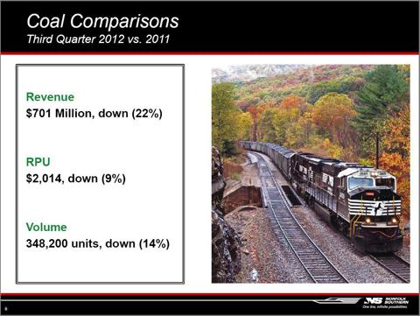
While some of the demand reduction reflects slowing exports and may reverse as the global economy recovers, much of it is driven by natural gas substitution, and will last as long as fracking continues to produce an abundant low-cost energy supply.
Over time, projects of this type will replace much of the lost revenue from decreasing coal shipments.

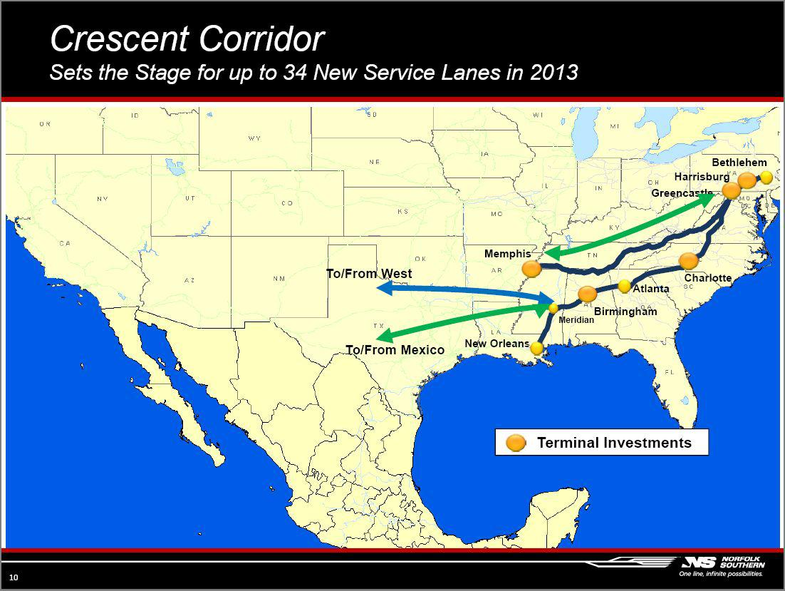
17.1.2013
Norfolk Southern - High Yield Link In The Railroad Pipeline
Railroads are a cyclical industry, especially Norfolk Southern (NSC) which traditionally was a coal hauler. Intermodal transportation smooths out the cyclicality somewhat, but the result is still cyclical.
Norfolk Southern Corporation, through its subsidiaries, engages in the rail transportation of raw materials, intermediate products, and finished goods primarily in the United States. Tom Armistead wrote a good analysis of the company "Why I Like Norfolk Southern For the Long Term" which details current metrics and issues.
Norfolk Southern is a Dividend Contender with 11 years of increasing dividends, a current yield of 3.23%, and a 5-yr dividend growth rate of 15.1%. The current P/E ratio is 11.24. The projected 5 year earnings per share growth rate is 12.7% and this year's earnings per share growth rate is 6.3%. I believe the stock is fairly valued at $73. However, I prefer a margin of safety and a 4% yield on a dividend growth stock. Therefore, I created a 5-yr dividend reinvestment table for this prospective holding:
The price cyclicality can be seen from this table. In addition, it also shows that the growing dividend purchased more shares during the downturn of 2008-2009 than were purchased at other times providing a form of dollar cost averaging. The $10,000 originally invested provided $13,407.29 after 5 years of quarterly reinvestment or 6% per year. These results are graphed below:
(click to enlarge)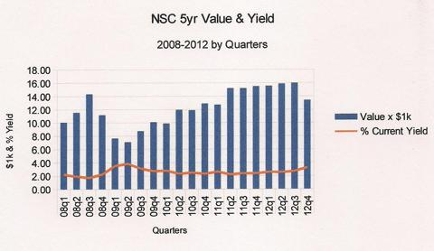
Conclusion: During the current business cycle, NSC appears to be heading down and a good buying point at 4% yield is possible. However, it can be seen by the chart that the stock has not reached 4% yield in the last 5 years. By setting a limit buy order anticipating the next dividend increase of 15.1%, I may be able to pick up this long-term holding at a 4% yield. The purchase price will be $57.55. In the long run, NSC should benefit from the global economy pickup, especially exports of oil, coal, and manufactures.
13.2.2013
Norfolk Southern (NSC)
Quality Rating - A
Yield + DGR = 3.23 + 15.1 = 18.33
Payout ratio 36%
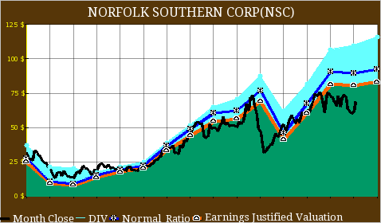

Formularende
Formularbeginn
Formularende
Formularende
Formularende
Formularende
Formularende

1.3.2013

Norfolk Southern's Coal Business Feels The Pinch Of Weak Utility And Export Demand
Norfolk Southern’s (NSC) earnings took a 10% hit in 2012, primarily due to a decline in coal freight revenues, which fell by 17% year-over-year. Despite this slowdown in coal freight, NSC’s coal division still raked in 26% of the firm’s total revenues, and makes up around a quarter of the company’s total value. We think that NSC’s reliance on coal freight is likely to suppress bottom line growth in 2013, as low natural gas prices and a slowdown in coal export demand will hurt coal freight demand during the year.
Coal Use For Utilities Declining
Norfolk Southern’s coal freight business is primarily reliant on coal used for generating electricity; coal for utilities made up approximately 65% of the coal that Norfolk Southern shipped in 2012. Utility coal tonnage fell by 17% in 2012, as low natural gas prices caused a substitution away from coal when it comes to energy production. This substitution of coal is troubling for NSC because if natural gas prices stay depressed for an extended period, utility companies could start shifting a material part of their electricity production to natural gas permanently. If this occurs, Norfolk Southern’s coal freight demand might not recover in the coming quarters, hurting the firm’s revenues through 2012.
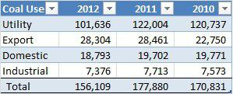
Coal Export Demand Will Also Slowdown
As can be seen from the table above, demand for coal export also slowed down during 2012, as weakness in the Chinese economy, the European Union and the United States ensured that global growth remained muted. Global growth fell to approximately 3% in 2012, and is expected to remain at this level in 2013.
However, it is important to note that global growth could miss these 3% estimates in 2013. The euro crisis has yet to see an end, and the outcome of the situation continues to remain uncertain. European GDP contracted 0.6% during Q4 2012, the third straight quarter of decline and the largest since Q1 2009. This situation, combined with the slowdown in China and India, is likely to have a negative effect on worldwide coal demand. We currently estimate that U.S. carloads of coal will fall to approximately 6.40 million in 2013, but if this number falls further to 5.5 million, we would see around 5% downside to our price estimate.
We currently have a $63 price estimate for Norfolk Southern, which is approximately 15% below the current market price.

8.3.2013
Norfolk Southern Feels The Pinch From Weaker Coal Demand
Norfolk Southern (NSC) is the leading railroad network in the Eastern United States engaged in the rail transportation of raw materials, intermediate products and finished goods. In 2012, its revenues stood at $11 billion with an operating margin of 28%. Owing to challenging conditions in the coal market, the company's top line faced continuous pressure during 2012. Unlike other railroads such as Union Pacific (UNP), the company was unable to offset volume decline with price rises. Its profitability also declined during 2012 due to a higher railway operating ratio.
Going forward, we feel challenging conditions in the coal market will continue to impact its volume and revenue per unit in the coming future. In addition, the expansion in its operating ratio will affect its bottom line in 2013.
Declining Revenues
Norfolk Southern's revenue recorded an annual decline of 4% and 7% in Q4 2012 and Q3 2012, respectively. Weakness in the coal business was the main factor responsible for this decline as revenues from its coal business dropped by around 22% in the last two quarters. Lower volume and a declining average revenue per unit have both contributed to this lower revenue.
- Declining Volume: Norfolk Southern's volume declined by 1% annually in the last two quarters. While coal shipments were lower by around 14% in the period, a 5% rise in intermodal shipments curbed some of the decline in overall volume. We expect challenging conditions in the coal market to weigh on Norfolk Southern's overall volume in 2013.
- Decreasing Average Revenue Per Unit: Norfolk Southern's revenue per unit fell by 5% and 3% annually in Q3 2012 and Q4 2012, respectively. We feel this RPU decline is especially troubling as other railroads such as Union Pacific were able to offset volume declines with price rises. If the company is not able to reverse this trend in the future, we feel NSC's revenues will further decline in the coming quarters.
Declining Profitability
Norfolk Southern's bottom line was hit harder than its top line in the recent period. Its net income dropped by 14% and 27% annually in Q4 2012 and Q3 2012, respectively. An increase in the railway operating ratio has contributed to this decline in profitability. Its railway operating ratio grew from 71.4% in Q4 2011 to 73.4% in Q4 2012. While the company announced cost-cutting initiatives in the latest earnings call, we will have to wait and see how this will impact its profitability in the coming quarters.
Weakness in Coal Market to Persist
Coal shipments account for around 26% of Norfolk Southern's revenue and contribute for around a quarter of its value. Owing to reduced demand by domestic utilities as well as lower export demand, the company saw a decline in coal shipments throughout 2012.
Coal for utilities comprised for 65% of the coal that Norfolk Southern shipped in 2012. However, the demand for coal by utilities has decreased as they are increasingly shifting to cheaper natural gas for producing electricity. Utility coal tonnage fell by 17% in 2012, and we feel that if natural gas prices continue to remain low, then NSC's coal freight business will remain constrained in the coming future.
Coal exports which account for 18% of the coal transported by Norfolk Southern recorded a marginal decline in 2012. Going forward, we feel coal exports will continue to stay under pressure due to uncertainty in the global economy. We currently forecast U.S. carloads of coal to decrease to around 6.40 million in 2013, but if this figure declines further to 5.5 million, it would represent 5% downside to our price estimat

1.4.2013
Formularende

How Much Is Norfolk Southern Worth?
Norfolk Southern (NSC) is one of the largest transportation companies in the country. The company operates the most extensive intermodal network in the East. It is also a key transporter of coal and industrial products. Norfolk Southern is doing well, and its stock reflects the performance of the company. However, we still think that it has substantial upside potential. In order to calculate the fair value of the stock, we decided to use our fair value model. Results of the model are discussed below.
As of the time of writing this article, NSC stock was trading at around $77, with a 52-week range of $56.05 - $77.42. It has a market cap of about $24.2 billion. The trailing twelve-month P/E ratio of 14.30 is above the forward P/E ratio of 11.10. P/B, P/S, and P/CF ratios stand at 2.5, 2.3, and 8.2, respectively. The operating margin is 28.3% while the net profit margin is 15.8%.
Norfolk Southern has a 3-star rating from Morningstar. Out of twenty eight analysts covering the stock, thirteen have buy recommendations and fifteen have hold recommendations. Average five-year annualized growth forecast estimate is 5%.
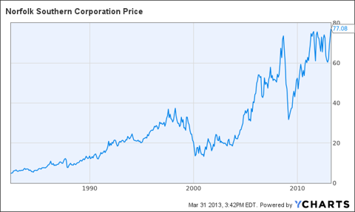
NSC data by YCharts
Summary
Norfolk has been rising since the start of the year. The stock has gained more than 20% year to date. According to our fair value model, it still has substantial potential. At the moment, the demand for transportation services is growing, which will allow the company to have strong pricing power. Investment in infrastructure will also allow the company to have higher growth in the long-term. Freight pricing is also strong, which has resulted in strong growth in intermodal and merchandise segments.
Currently, the stock offers a dividend yield of over 2.5%, which is an attractive one for dividend-growth investors.

10.4.2013
Norfolk Southern: Railroad Offers Value And Solid Dividend Yield
I continue to be skeptical of the recent market rally for reasons I have articulated recently. However, as the saying goes, one has to dance as long as the music is playing, and I have more than a prudent level of cash in my portfolio already. As funds get returned into my account as options expire in the money, one area I think still has value is the railroads. The housing recovery and buoyant domestic auto production bodes well for demand. In addition, the sector offers better valuations and growth prospects, as well as similar dividend yields to some of the overbid Consumer Staples names like Procter & Gamble (PG). For income investors, I believe the sector offers better value than some of the defensive sectors (Utilities & Consumer Staples) that are usually the refuge of dividend investors. One railroad that looks like a good value here is Norfolk Southern (NSC) due to some recent positives, reasonable valuation and solid and growing dividend yield
Norfolk Southern operates 20,000 route miles serving 22 eastern states, the District of Columbia, and Ontario, Canada.
4 additional reasons NSC still offers solid value at $75 a share:
- The shares yield 2.7%. As importantly, Norfolk has increased its dividend payouts at just under 12% annually over the past five years.
- A value investor gets this yield for less than 14x forward earnings. Compare this to Procter & Gamble, which yields 2.9% but sells for 18x forward earnings. NSC has also increased its dividend 50% faster than PG over the last half decade.
- The company has met or beat earnings estimates for six straight quarters and the stock has a reasonable five year projected PEG (1.28) for an almost three percent yielder.
- S&P has a "Buy" rating on the stock and Credit Suisse is at "Outperform" on the shares. Both Deutsche Bank and Dahlman Rose upgraded the shares from "Hold" to "Buy" in the first quarter.
Formularende

10.4.2013
Coke's North America Market Wants Healthy Alternatives
Coca-Cola (KO) will make a transformation over the next decade that will see a larger chunk of its revenue source comes from healthy drinks as the soft drink arena continues to decline, especially in America. Let's explore this battle that's going on in our culture and see how the company is handling it. It is readily observable in the company's fourth-quarter numbers.
Fourth-quarter earnings just barely beat analyst expectations.
- Earnings grew by 15%.
- Revenue growth came in at 11.04 billion, just under analyst expectations.
- Currency headwinds weren't as bad as expected, which helped earnings as increased volume for the quarter was offset by flat pricing.
With a so-so fourth quarter, estimates in 2013 have been moving down like they have for many companies this year. Analysts' 2013 estimates were revised downward by 1% and in 2014 they were revised by about 0.9% downward. Much of this can be attributed to the weakening in consumer spending.
Sparkling Beverage Challenges
On the one hand Americans are drinking more non-alcoholic beverages than ever before. In 2012 Americans bought an extra 1% of these beverages over the year before, unfortunately it's not Pepsi or Coke that are reaping the benefits. It appears that the constant attack on soft drinks (thank you Mayor Bloomberg) is leading to a decline in the sales of soft drinks as Americans are turning toward water, teas and other alternatives.
Through the 1990s the soft drinks continued to grow in popularity at a clip of about 3% a year. Transitioning into the 2000s, soft drinks have been struggling, declining since about 2005. Here are some recent statistics of this decline:
- 2012 saw a third straight year of decline as sales dropped 1.2%
- Soft drinks dropped 1% in 2011
- 2010 saw a drop of 0.5%
- 2012 carbonated drink sales (by the gallon) was 12.3 billion gallons as compared to 12.6 billion gallons in 2011 and this is the eighth consecutive year of decline
While soft drinks may have declined, healthy alternatives appear to be growing. Dasani water increased by 11% in 2012 while Arizona Tea also expanded by 9.3%.
It is a fact, Americans are turning to healthier drinks like water, ready to drink teas, coffee and sports drinks. This is the new alternative to sipping on soft drinks and fruit drinks like we have done in the past. Gatorade, the fifth-largest brand in America, has been the fastest-growing sports drink while bottled water just continues to capture pieces of the beverage market. Its volume levels grew at 3.5% in 2010 and 4.1% in 2011.
Coke Looks to Healthier Drinks
Recognizing the need to offer healthier beverages; the company is working on such alternatives as: Simply Orange, Honest Tea and Powerade. While North America saw an increase of 1% last quarter in total sales for Coke, it was not in soft drink beverages, which fell by 2%. An 8% increase in the demand for alternative drinks led by Powerade carried the company.

