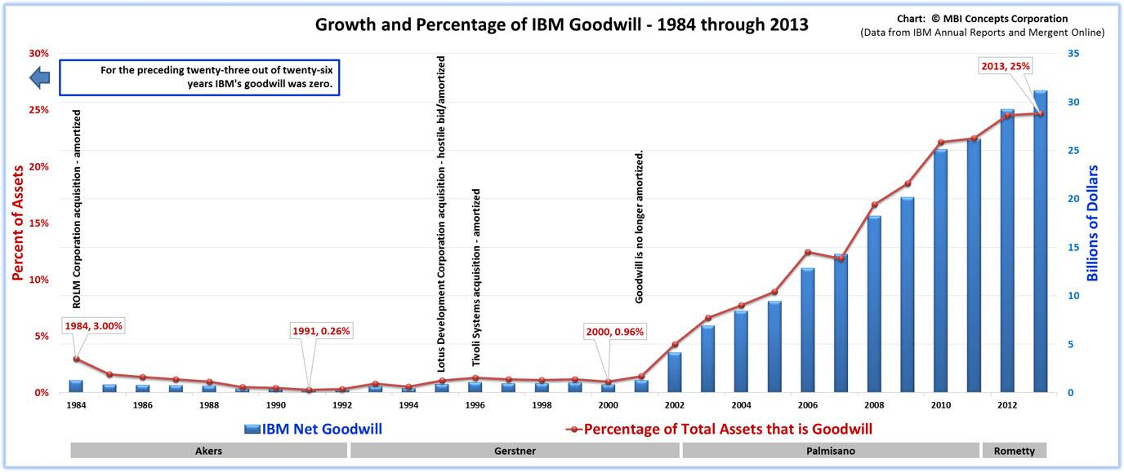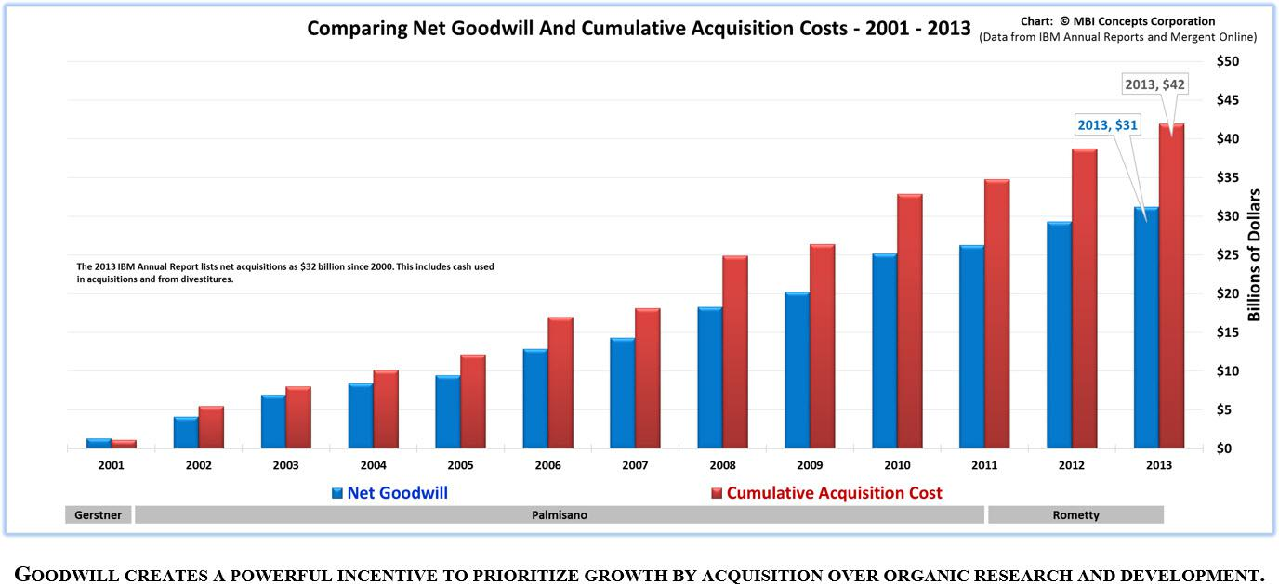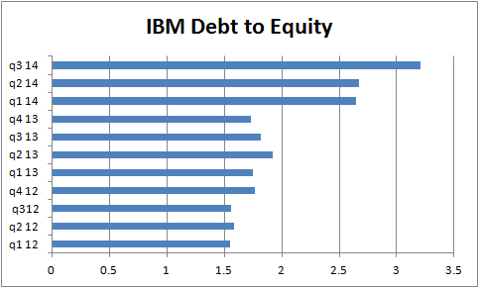
Ohne Rückkäufe stagniert der EPS
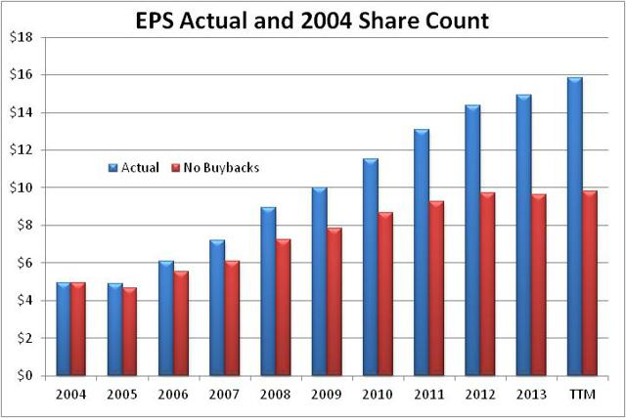
5.) Geben mehr Geld für Aktienrückkäufe und Dividenden aus, als sie FCF haben.
In 2013, IBM repurchased $13.86 Billion in stock and paid $4.06 Billion in dividends with only $12.5 Billion in free cash flow. IBM returned $5.92 Billion more to shareholders than it generated in free cash flow. Paying out more than 100% of FCF requires surplus cash or the issuance of debt.
8.) 1966 wurden in Technologie investiert. 2013 nur in Aktienrückkäufe
IBM spent 9.50 times its 1966 net income over four years to produce the mainframe - $5,000,000,000 in research, development and capital investments. IBM spent 9.59 times its 2013 net income over fourteen years buying its own stock - $158,000,000,000 in gross share repurchases. Within the history of a single company we see two completely different leadership styles: one that was sales-minded and invested in people, products and processes; a second that was financially minded and invested in paper
10.) In 31 Quartalen wurden 111 Mrd für Aktienrückkäufe und 23 Mrd für Dividenden ausgegeben, der FCF war aber nur 107 Mrd.
During the 31 quarters since the end of 2006, IBM has spent $111 billion on share buybacks and another $23 billion on dividends. During this same nearly eight year period, IBM reported net income of only $107 billion. So its paid out 125% of its earnings to shareholders
11.) in 20 Jahren wurden 550 Mio Aktien rückgekauft. 40 % gingen sofort an das Management.
This massive and continuous stock-buying program brought approximately 550 million, or 36 percent, of the company’s 1.5 billion of outstanding shares into its treasury, but needless to say, they did not all stay there. Nearly two-fifths of these shares reentered the float, mainly to refresh the management stock option kitty.

